

**ACADEMIC YEAR : 2020-2021**

**DEPARTMENT: RE**

**LEVEL : III**

**MODULE CODE: REN302**

**MODULE NAME: AUTOMATION CONTROL SYSTEM**

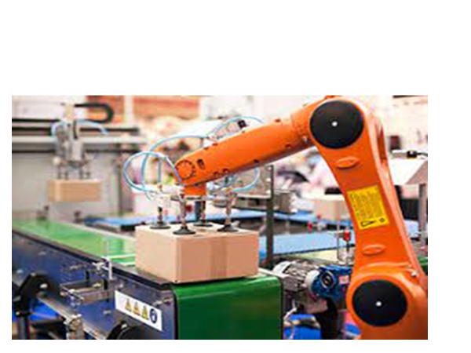

STUDENT’S HANDOUT

PREPARED BY ENG. NIYITEGEKA JANVIER

Contents

CHAP I: INTRODUCTION TO CONTROL SYSTEMS 5

1.0 What is Automatic Control? 5

1.1 Automation System 6

1.2 Types of Automation Systems 7

1.3 Control System 8

1.4. ARCHITECTURE OF INDUSTRIAL AUTOMATION SYSTEMS 9

1.4.1 The Functional Elements of Industrial Automation 9

1.4.2 The Layers/levels of Industrial Control and Automation: 15

1.5 Classification of Control Systems 17

1.5.1 Man-made(Manual) control system 17

1.5.2 Automatic Control Systems 17

1.5.3 Time-variant control system and Time-invariant control system 17

1.5.4 Single-input-single-output control system and Multi-input-multi-output control system 17

1.5.5. Open-loop control system and Closed-loop control system 18

1.5.6 Linear control system and Non-linear control system 22

CHAP II: INDUSTRIAL SENSORS MEASUREMENTS 23

2.1 Sensor Systems: 23

2.1.1 Temperature Measurement 24

2.1.2 Displacement and Speed Measurement 31

2.1.3 Measurement of Level, Humidity and pH 40

2.1.4 Optical and Radiation Sensors 44

• The Photodiode. 44

• Light Sensor Module Interface With Arduino 47

2.1.5 Position and Motion Sensors 48

2.2 SIGNAL CONDITIONING CIRCUITS 50

2.2.1 Wheatstone Bridge 51

2.2.4 Amplifiers 52

CHAP III: INDUSTRIAL ACTUATORS 55

3.1 Relay 55

3.2 DC Motor 56

3.3 Stepper Motor 58

3.4 Pneumatic and Hydraulic Actuators 61

3.4.1 Directional Control Valves 62

3.5 ACTUATORS APPLICATIONS 65

3.5.1 A conveyor belt 65

3.5.2 A robot control system 66

CHAP IV: PROGRAMMABLE LOGIC CONTROL SYSTEMS 67

4.0 Introduction 67

4.1 Sequence and Logic Control 67

4.2. Discrete Sensors and Actuators 67

4.3. PROGRAMMABLE LOGIC CONTROLLERS (PLC) 69

4.3.1. Introduction 69

4.3.2 SCADA Control System 71

4.3.3 EVOLUTION OF PLC 72

4.3.4 PLC ADVANTAGES OVER CONTROL PANNELS 73

4.3.5 Application Areas 74

4.3.6 TYPES OF PLCs 75

3.4.1 Compact PLC 75

3.4.2 Modular PLC 75

4.3.7 PLC Hardware 76

4.3.8. CPU Module 78

4.3.9. Power supply: 78

4.3.10 Memory Module 78

4.3.10. Programming Unit: 79

4.3.11. Indicator lights 79

4.3.12. Input and output modules: 79

4.3.13. Communication Interface 83

4.4. PLC Internal architecture 84

4.5. Operation of PLC: 86

4.5.1 Update the input/outputs: 86

4.5.2 Solve the Ladder logic: 87

4.5. PLC Programming 87

4.3.14.1 Structure of a PLC Program 87

4.3.15. Programming Languages 90

4.3.16. PLC LADDER LOGIC PROGRAMMING 91

Questions and Exercises 107

Assigment1 112

CHAP V: CONTROL SYSTEMS MODELLING 112

5.1. Introduction to Process Control 112

5.2. Characteristics of a Process 113

5.3. Laplace Transform 114

5.4. Transfer function 117

5.5 System Block Diagram 119

5.6. P-I-D Control 122

5.7. Proportional control 123

5.8. Integral Control 124

5.9. Proportional Plus Integral (P-I) Control 126

5.10. Proportional plus Derivative (P-D) Control 126

5.11. Proportional-Integral-Derivative (PID) control 127

5.12. Selection of controller mode 128

5.13. Controller Tuning 129

5.13.1. Closed Loop Technique (Continuous Cycling method) 130

5.13.2. Electronic PID Controllers 131

# CHAP I: INTRODUCTION TO CONTROL SYSTEMS

## What is Automatic Control?

Automatic control is the technology used to control processes in order to achieve desired behaviors. In many principal disciplines of science, such as physics and mechanics, we learn to understand how nature works. We observe, and mathematically describe, various phenomenon in our environment. In automatic control we use this knowledge to control these phenomena.

From mechanics we have for instance obtained equations, which describe the velocity of a cart rolling down an inclined plane. In control theory the corresponding equations can be used to device an automatic cruise controller for motorcars, granting them constant speed, despite variations in the incline of the road. Automatic control is used in a variety of ways. Here are some examples:

* To keep a constant temperature in buildings, despite variations in the outdoor temperature and the number of persons in the building, is a classic control problem.
* In the process industry, e.g. in pulp mills, hundreds—or even thousands— of controllers maintain desired pressures, flows, temperatures, concentrations and levels.
* Modern cars contain many control systems for e.g. cruise control, anti-lock brake systems, power steering, emission reduction and air conditioning.
* Cameras contain control systems for e.g. auto focus and automatic exposure control.
* A DVD player contains controllers which ensure that the laser beam follows the track. This is an advanced control problem, especially as the DVD player is sometimes found in a mobile unit, subject to mechanical shocks.
* Automatic control is not limited to technological contexts. The human body, for instance, contains many control systems. One example is the temperature control, which ensures that the body temperature is held constant at 37○ C, despite variations in the surrounding temperature and the work load of the body. Another example is the light control in the eye. The size of the pupil is automatically adjusted so that the illumination of the retina is held as constant as possible.

Referring to the title of the module given, the module gives a focus on three important words that include *“****Automation”, “Control” and “Systems***”. The details about these words are being described in the following paragraphs.

## 1.1 Automation System

The word ‘**Automation**’ is derived from greek words “**Auto**”(self) and “Matos” (**moving**). Automation therefore is the mechanism for systems that “move by itself”. Therefore, by definition “**Automation**” is a set of technologies that results in operation of machines and systems without significant human. The machine can be applied to the tasks that could be performed by human beings or to tasks that would otherwise be impossible. Although the term mechanization is often used to refer to the simple replacement of human labour by machines, automation generally implies the integration of machines into a self-governing system.

In the scope of industrialization, automation is a step beyond *mechanization*. Whereas mechanization provided human operators with machinery to assist them with the muscular requirements of work, automation greatly reduces the need for human sensory and mental requirements as well.

Industrial Automation is a discipline that includes knowledge and expertise from various branches of engineering including electrical, electronics, chemical, mechanical, communications and more recently computer and software engineering. In addition to the industrial production with it is popularly associated, it now covers a number of unexpected areas. Trade, environmental protection engineering, traffic engineering, agriculture, building engineering, and medical engineering are but some of the areas where automation is playing a prominent role. Automation engineering is a cross sectional discipline that requires proportional knowledge in hardware and software development and their applications. In the past, automation engineering was mainly understood as control engineering dealing with a number of electrical and electronic components. This picture has changed since computers and software have made their way into every component and element of communications and automation.

*Specialized industrial computers*, referred to as programmable logic controllers (PLCs), are

frequently used to synchronize the flow of inputs from (physical) sensors and events with the

flow of outputs to actuators and events. This leads to precisely controlled actions that permit

a tight control of almost any industrial process.

Human-machine interfaces (HMI) or computer human interfaces (CHI), formerly known

as man-machine interfaces, are usually employed to communicate with PLCs and other

computers, such as entering and monitoring temperatures or pressures for further automated

control or emergency response. Service personnel who monitor and control these interfaces

are often referred to as stationary engineers.

## 1.2 Types of Automation Systems

Automation systems can be categorized based on the flexibility and level of integration in manufacturing process operations. Thus, various automation systems can be classified as follows:

1. **Fixed Automation**:It is used in high volume production with dedicated equipment, which has a fixed set of operation and designed to be efficient for this set. Continuous flow and Discrete Mass Production systems use this automation. e.g. Distillation Process, Conveyors, Paint Shops, Transfer lines etc. A process using mechanized machinery to perform fixed and repetitive operations in order to produce a high volume of similar parts.
2. **Programmable Automation:** It is used for a changeable sequence of operation and configuration of the machines using electronic controls. However, non-trivial programming effort may be needed to reprogram the machine or sequence of operations. Investment on programmable equipment is less, as production process is not changed frequently. It is typically used in Batch process where job variety is low and product volume is medium to high, and sometimes in mass production .
3. **Flexible Automation**: It is used in Flexible Manufacturing Systems (FMS) which is invariably computer controlled. Human operators give high-level commands in the form of codes entered into computer identifying product and its location in the sequence and the lower level changes are done automatically. Each production machine receives settings/instructions from computer. These automatically loads/unloads required tools and carries out their processing instructions. After processing, products are automatically transferred to next machine. It is typically used in job shops and batch processes where product varieties are high and job volumes are medium to low.
4. ***Integrated Automation:***It denotes complete automation of a manufacturing plant, with all processes functioning under computer control and under coordination through digital information processing. It includes technologies such as computer-aided design and manufacturing, computer-aided process planning, computer numerical control machine tools, flexible machining systems, automated storage and retrieval systems, automated material handling systems such as robots and automated cranes and conveyors, computerized scheduling and production control. It may also integrate a business system through a common database.

## 1.3 Control System

**Definition:** The term Control is defined as a set of technologies that achieves desired patterns of operational parameters and sequences for machines and systems by providing the necessary input signals. An interconnection of components forming a system configuration that will provide a desired response.

**Difference between Automation System and Control System:**

* Automation Systems may include Control Systems but the reverse is not true. Control Systems may be parts of Automation Systems.
* The main function of control systems is to ensure that outputs follow the set points. However, Automation Systems may have much more functionality, such as computing set points for control systems, monitoring system performance, plant startup or shutdown, job and equipment scheduling etc.
* Automation Systems are essential for most modern industries. It is therefore important to understand why they are so, before we study these in detail in this course.

## 1.4. ARCHITECTURE OF INDUSTRIAL AUTOMATION SYSTEMS

### 1.4.1 The Functional Elements of Industrial Automation

An Industrial Control and Automation System consists of numerous elements that perform a variety of functions related to the industrial process. These elements may also communicate with one another to exchange information necessary for overall coordination and optimize operation of the plant/factory/process. Below, we classify the major functional elements typically and also describe the nature of technologies that are employed to realize the functions.

#### 1.4.1.1 Sensing and Actuation Elements

These elements interface directly and physically to the process equipment and machines. The sensing elements translate the physical process signals such as temperature, pressure or displacement to convenient electrical or pneumatic forms of information, so that these signals can be used for analysis, decisions and finally, computation of control inputs. These computed control inputs, which again are in convenient electrical or pneumatic forms of information, need to be converted to physical process inputs such as, heat, force or flow-rate, before they can be applied to effect the desired changes in the process outputs. Such physical control inputs are provided by the actuation elements.

##### **Industrial Sensors Systems**

Scientific and engineering sensors and instrument systems of a spectacular variety of size, weight, cost, complexity and technology are used in the modern industry. However, a close look would reveal that all of them are composed of a set of typical functional elements connected in a specified way to provide signal in a form necessary. Fig 1.1 below shows the configuration of a typical sensor system.

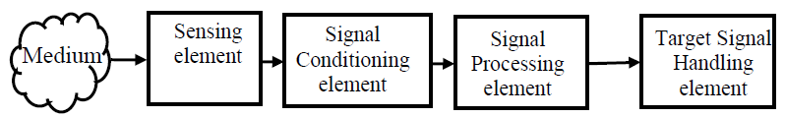

Fig1.1. **Functional configuration of a typical sensor system**

In Fig. 1.1 a sensor system is shown decomposed into three of its major functional components, along with the medium in which the measurement takes place. These are described below.

1. **The physical medium**

This refers to the object where a physical phenomenon is taking place and we are interested in the measurement of some physical variable associated with the phenomenon. Thus, for example, the physical medium may stand for a furnace in the case of temperature measurement or the fluid in a pipe section in the case of measurement of liquid flow rate.

1. **The sensing element**

Itis affected by the phenomenon in the physical medium either through direct or physical contact or through indirect interaction of the phenomenon in the medium with some component of the sensing element. Again, considering the case of temperature measurement, one may use a thermocouple probe as the sensing element that often comes in physical contact with the hot object such as the flue gas out of a boiler-furnace or an optical pyrometer which compares the brightness of a hot body in the furnace with that of a lamp from a distance through some window and does not come in direct contact with the furnace.

In the more common case where the sensing element comes in contact with the medium, often some physical or chemical property of the sensor changes in response to the measurement variable. This change then becomes a measure of the physical variable of interest. A typical example is the change in resistivity due to heat in a resistance thermometer wire. Alternatively, in some other sensors a signal is directly generated in the sensing element, as is the case of a thermocouple that generates a voltage in response to a difference in temperature between its two ends.

1. **The signal-conditioning element**

This serves the function of altering the nature of the signal generated by the sensing element. Since the method of converting the nature of the signal generated in the sensor to another suitable signal form (usually electrical) depends essentially on the sensor, individual signal conditioning modules are characteristic of a group of sensing elements.

For example consider a resistance Temperature Detector (RTD) whose output response is a change in its resistance due to change in temperature of its environment. This change in resistance can easily be converted to a voltage signal by incorporating the RTD in one arm of a Wheatstone's bridge. The bridge therefore serves as a signal-conditioning module. Signal conditioning modules are also used for special purpose functions relating to specific sensors but not related to variable conversion such as `ambient referencing' of thermocouples. These typically involve analog electronic circuits that finally produce electrical signals in the form of voltage or current in specific ranges.

1. **The signal processing element**

This is used to process the signal generated by the first stage for a variety of purposes such as, **filtering** (to remove noise), **diagnostics** (to assess the health of the sensor), **linearization** (to obtain an output which is linearly related with the physical measured etc. Signal processing systems are therefore usually more general purpose in nature.

1. **The target signal-handling element**

It may perform a variety of functions depending on the target application. It may therefore contain data/signal display modules, recording or/storage modules, or simply a feedback to a process control system. Examples include a temperature chart recorder, an instrumentation tape recorder, a digital display or an Analog to Digital Converter (ADC) followed by an interface to a process control computer.

Modern sensors often have the additional capability of digital communication using serial, parallel or network communication protocols. Such sensors are called “smart” and contain embedded digital electronic processing systems.

##### Industrial Actuator Systems

Actuation systems convert the input signals computed by the control systems into forms that can be applied to the actual process and would produce the desired variations in the process physical variables. In the same way as in sensors but in a reverse sense, these systems convert the controller output, which is essentially information without the power, and in the form of electrical voltages (or at times pneumatic pressure) in two ways. Firstly it converts the form of the variable into the appropriate physical variable, such as torque, heat or flow.

Secondly it amplifies the energy level of the signal manifold to be able to causes changes in the process variables. Thus, while both sensors and actuators cause variable conversions, actuators are high power devices while sensors are not. It turns out that in most cases, actuators are devices that first produce motion from electrical signal, which is then further converted to other forms. Based on the above requirement of energy and variable conversion most actuation systems are structured as shown in Fig. 1.2.

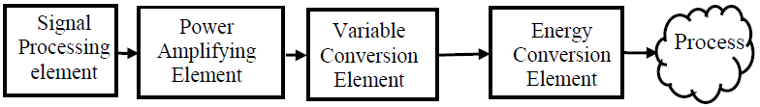Fig.1.2. **Functional configuration of a typical actuator system**

An actuator system is shown decomposed into its major functional components, The salient points about the structure are described below.

1. ***The electronic signal-processing element***

It accepts the command from the control system in electrical form. The command is processed in various ways. For example it may be filtered to avoid applying input signals of certain frequencies that may cause resonance. Many actuators are themselves closed feedback controlled units for precision of the actuation operation. Therefore the electronic signal-processing unit often contains the control system for the actuator itself.

1. ***The electronic power amplification element***

Sometimes it contains linear power amplification stages called servo-amplifiers. In other cases, it may comprise power electronic drive circuits such as for motor driven actuators.

1. ***The variable conversion element***

It serves the function of altering the nature of the signal generated by the electronic power amplification element from electrical to non-electrical form, generally in the form of motion. Examples include electro-hydraulic servo valve, stepper/servo motors, Current to Pneumatic Pressure converters etc.

1. ***The non-electrical power conversion elements***

Theyare used to amplify power further, if necessary, typically using hydraulic or pneumatic mechanisms.

1. ***The non-electrical variable conversion elements***

**It**may be used further to transform the actuated variable in desired forms, often in several stages. Typical examples include motion-to-flow rate conversion in flow-valves, rotary to linear motion converters using mechanisms, flow-rate to heat conversion using steam or other hot fluids etc.

#### 1.4.1.2 Automatic Control systems

By industrial control systems, we denote the sensors systems, actuator systems as a controller. Controllers are essentially elements that accept command signals from human operators or Supervisory Systems, as well as feedback from the process sensors and produce or compute signals that are fed to the actuators.

#### 1.4.1.3 Supervisory Control

Supervisory control performs at a hierarchically higher level over the automatic controllers, which controls smaller subsystems. Supervisory control systems perform, typically the following functions:

* **Set point computation:** Set points for important process variables are computed depending on factors such as nature of the product, production volume, mode of processing. This function has a lot of impact on production volume, energy and quality and efficiency.
* **Performance Monitoring / Diagnostics**: Process variables are monitored to check for possible system component failure, control loop detuning, process parameter change etc. Based on the process of input/output, the supervisory controller does a lot of calculations to check always whether the system is working nicely. If it finds some problems, it immediately gives various commands to ensure which controller to use and when. The supervisory controller manages a number of automatic controllers.
* **Start up / Shut down / Emergency Operations :** Special discrete and continuous control modes are initiated to carry out the intended operation, either in response to operator commands or in response to diagnostic events such as detected failure modes.
* **Control Reconfiguration / Tuning:** Structural or Parametric redesign of control loops are carried out, either in response to operator commands or in response to diagnostic events such as detected failure modes. Control reconfigurations may also be necessary to accommodate variation of feedback or energy input e.g. gas fired to oil fired.
* **Operator Interface:** Graphical interfaces for supervisory operators are provided, for manual supervision and intervention.

#### 1.4.1.4 Production Control

Production control performs at a hierarchically higher level over the supervisory controllers. Typical functions they perform are:

* **Process Scheduling:** Depending on the sequence of operations to be carried on the existing batches of products, processing resource availability for optimal resource utilization.
* **Maintenance Management:** Decision processes related to detection and deployment of maintenance operations.
* **Inventory Management**: Decision processes related to monitoring of inventory status of raw material, finished goods etc. and deployment of operations related to their management.
* **Quality Management :** Assessment, Documentation and Management of Quality

### 1.4.2 The Layers/levels of Industrial Control and Automation:

Industrial automation systems are very complex having large number of devices with confluence of technologies working in synchronization. In order to know the performance of the system we need to understand the various parts of the system. Industrial automation systems are organized hierarchically. Here is a brief description of the various levels of the industrial

automation.

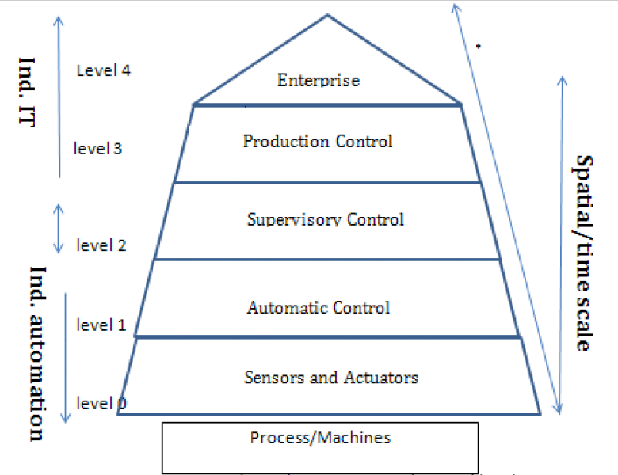

Fig.1.3. **Layers of industrial automation(Automatic Pyramid)**

Various components in an industrial automation system can be explained using the automation pyramid as shown above. Here, various layers represent the wideness ( in the sense of no. of devices ), and fastness of components on the time-scale.

1.4.2.1 Sensors and Actuators Layer***:***

This layer is closest to the process and machines, used to translate signals so. The field level describes all terminal equipment such as sensors and actuators (magnetic valves, power switches, motor starters, etc.) collaborating with a peripheral PLC or remote I/O system, offering pre-procession of the collected data and communication to the main PLC via field bus. Communication between a peripheral PLC and the end device is usually a point‑to point. Also wireless solutions (RFID, wireless sensor networks) are used for special cases.

#### 1.4.2.2 Automatic Control Layer:

This layer consists of automatic control and monitoring systems, which drive the actuators using the process information given by sensors. This level describes the automation systems (programmable logic controller –PLC) where automation programs are executed. Systems related to this level require high real-time capability and are based on a special controller architecture with its own proprietary OS running on it. For enlargement of the operation range there are so-called peripheral controllers installed, which communicate to the (main) PLC via field bus; these systems also take over some pre-processing of I/O data to reduce the working load of the main PLC.

#### 1.4.2.3 Supervisory Control Layer:

This layer drives the automatic control system by setting target/goal to the controller. Based on the process of input/output, the supervisory controller does a lot of calculations to check always whether the system is working nicely. If it finds some problems, it immediately gives various commands to ensure which controller to use and when. The supervisory controller manages a number of automatic controllers.

Within this level there are mainly PC-based systems used (so-called industrial PC, available as desktop, rack-mounted and panel PCs), equipped with standard OS (e.g., Windows-embedded) and supplier-specific industrial process-control software for process parameterization and visualization.

#### 1.4.2.4 Production Control Layer:

This solves the decision problems like production targets, resource allocation, task allocation to machines, maintenance management etc. This is called ‘level 3’ layer.

#### 1.4.2.5 Enterprise control layer:

This deals less technical and mainly concerned with management functions, like supply, sales, demand, cash flow, product marketing etc. This is called as the ‘level 4’ layer.

In that sense, the layers up to, from some parts of the supervisory control as well as production control and enterprise control could be tuned *as industrial information technology* rather than industrial automation technology (Fig.1.3). Because automation has a kind of hardware and software flavor. On the other hand, information technology (IT) has also a lot of technology, optimization technology but they are not concerned about hardware. It is not real time technology.

## 1.5 Classification of Control Systems

### 1.5.1 Man-made(Manual) control system

It is a control system that is created by humans, i.e. automobile, power plants etc.

### 1.5.2 Automatic Control Systems

It is a control system that is made by using basic theories from mathematics and engineering. This system mainly has sensors, actuators and responders.

### 1.5.3 Time-variant control system and Time-invariant control system

**Time-variant control system:** It is a control system where any one or more parameters of the control system vary with time i.e. driving a vehicle.

**Time-invariant control system**: It is a control system where none of its parameters vary with time i.e. control system made up of inductors, capacitors and resistors only.

### 1.5.4 Single-input-single-output control system and Multi-input-multi-output control system

**SISO control system:** It is a control system that has only one input and one output.

**MIMO control system:** It is a control system that has only more than one input and more than one output.

### 1.5.5. Open-loop control system and Closed-loop control system

#### 1.5.5.1 Open Loop Control System

Open Loop Control System is a control system where the control action is totally independent of output of the system. It is a control system where its control action only depends on input signal and does not depend on its output response. Manual control system is open loop system. The following figure shows the block diagram of open loop control system in which process output is totally independent of controller action.

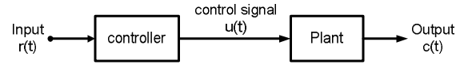

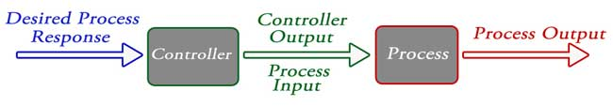

Fig.1.4: Open Loop Control System

**Advantages:**

* Simple design and easy to construct
* Economical
* Easy for maintenance
* Highly stable operation

**Disadvantages:**

* Not accurate and reliable when input or system parameters are variable in nature
* Recalibration of the parameters are required time to time

***Practical Examples of Open Loop Control System:***

**Electric Hand Drier** – Hot air (output) comes out as long as you keep your hand under the machine, irrespective of how much your hand is dried.

**Automatic Washing Machine** – This machine runs according to the pre-set time irrespective of washing is completed or not.

**Automatic Tea/Coffee Maker** – These machines also function for pre adjusted time only.

**Light Switch** – lamps glow whenever light switch is on irrespective of light is required or not.

**Volume on Stereo System** – Volume is adjusted manually irrespective of output volume level.

#### 1.5.5.2 Closed Loop Control System

It is a control system where its control action depends on both of its input signal and output response. It is a control system in which the output has an effect on the input quantity in such a manner that the input quantity will adjust itself based on the output generated. Open loop control system can be converted in to closed loop control system by providing a feedback which automatically makes the suitable changes in the output due to external disturbance.

In this way closed loop control system is called automatic control system. Figure below shows the block diagram of closed loop control system in which feedback is taken from output and fed in to input.

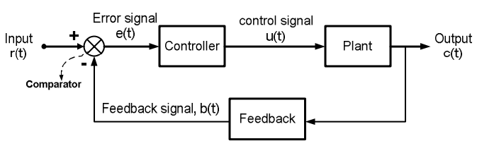

*Fig.1.5: Closed Loop Control System*

**Advantages:**

* More accurate operation than that of open-loop control system
* Can operate efficiently when input or system parameters are variable in nature
* Less nonlinearity effect of these systems on output response
* High bandwidth of operation
* There is facility of automation
* Time to time recalibration of the parameters are not required

***Disadvantages:***

* Complex design and difficult to construct
* Expensive than that of open-loop control system
* Complicate for maintenance
* Less stable operation than that of open-loop control system

**Practical Examples of Closed Loop Control System:**

1. **Automatic Electric Iron** – Heating elements are controlled by output temperature of the iron.
2. **Water Level Controller**– Input water is controlled by water level of the reservoir..
3. **An Air Conditioner** – An air conditioner functions depending on the room’stemperature.
4. **Cooling System in Car** – It operates depending upon the temperature which it controls.

**Comparison of Closed Loop and Open Loop Control System:**

It is a control system where its control action depends on both of its input signal and output response.

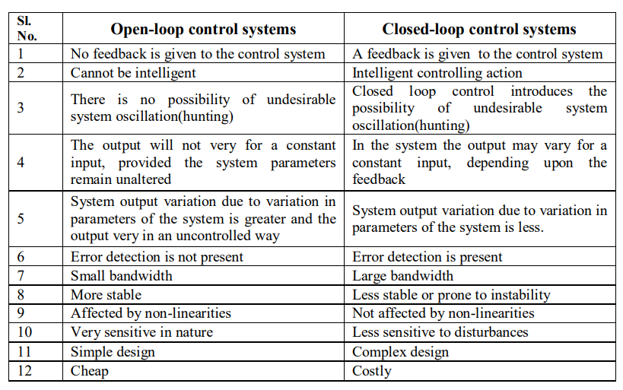

For industry automation system, we may want to automate the process; we may also like to control certain parameters of the system output (level of a tank, pressure of steam etc.). Broadly speaking, there could be **two types of control;** we might want to carry out. The first one is called ***sequential control***, where the control action is carried out in a sequence. A good example for this type of operation could be in an automated car manufacturing system, where the assembly of parts is carried out in a sequence (on a conveyor line). Here the control action is sequential in nature and works in a preprogrammed open loop fashion (implying that there is no feedback of the output signal to the controller). Programmable Logic Controller (PLC) is often used to carry out these operations.

But there are cases, where the control action needed is **continuous in nature and precise control of the output variable** is required. Take for example, the drum level control of a boiler. Here, the water level of the drum has to be maintained within a small band, in spite of variations of steam flow rate, steam pressure etc. This type of control is sometimes called ***modulating control***, as the control variable is *modulated* to keep the process variable at a constant value. Feedback principle is used for these types of control. We would concentrate on the control of these types of processes. But in order to design a controller effectively, we must have a complete knowledge about the dynamics of the process. A mathematical model of the process dynamics often helps us to understand the process behaviour under different operational conditions.

### 1.5.6 Linear control system and Non-linear control system

**Linear control system:** It is a control system that satisfies properties of homogeneity and additive.

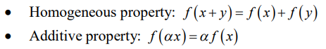

**Non-linear control system**: It is a control system that does not satisfy properties of homogeneity and additive. 

# CHAP II: INDUSTRIAL SENSORS MEASUREMENTS

A ***sensor*** is a device that converts a physical phenomenon into an electrical signal. As such, sensors represent part of the interface between the physical world and the world of electrical devices, such as computers. The other part of this interface is represented by ***actuators***, which convert electrical signals into physical phenomena. ***TRANSDUCERS Convert*** One Type of Energy into Another .The terms are often Interchanged

## 2.1 Sensor Systems:

Based on their need for power supply. The sensors are of two types : **Active Sensors** which require an external Source of excitation such as RTDs, Strain-Gages and **Passive (Self-Generating) Sensors** that do not need an external power source: Thermocouples, Photodiodes, Piezoelectric.

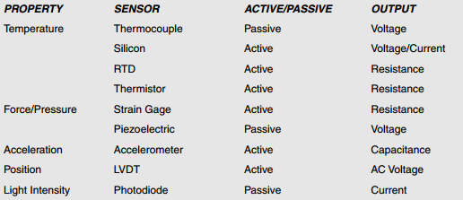

The full-scale outputs of most sensors (**passive or active**) are relatively small voltages,  
currents, or resistance changes. Therefore their outputs must be properly conditioned before further analog or digital processing can occur. Because of this, an entire class of circuits have evolved, generally referred to as ***signal conditioning*** circuits. Amplification, level translation, impedance transformation, linearization, and filtering are fundamental signal conditioning functions that may be required.

### 2.1.1 Temperature Measurement

Temperature is defined as a specific degree of hotness or coldness as referenced to a specific scale. It can also be defined as the amount of heat energy in an object or system. Temperature sensors detect a change in a physical parameter such as resistance or output voltage that corresponds to a temperature change.

Within the limited scope of this unit, we shall discuss few of the temperature sensors that are useful for measurement in industrial environment.

**There are two basic types of temperature sensing:**

1. **Contact** temperature sensing requires the sensor to be in direct physical contact with the media or object being sensed. It can be used to monitor the temperature of solids, liquids or gases over an extremely wide temperature range.
2. **Non-contact** measurement interprets the radiant energy of a heat source in the form of energy emitted in the infrared portion of the electromagnetic spectrum. This method can be used to monitor non-reflective solids and liquids but is not effective with gases due to their natural transparency.

#### 2.1.1.1 Temperature Sensor Types and Technologies

Temperature sensors comprise three families: **electro-mechanical**, **electronic**, and **resistive**. The following sections discuss how each sensor type is constructed and used to measure temperature and humidity.

1. **Electro-mechanical**

The bi-metallic switch is a discrete (on-off) sensor that takes advantage of the fact that as materials are heated they expand, and that for the same change in temperature, different types of material expand differently.

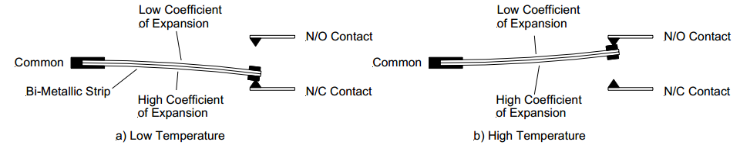

**Fig.2.1. Bi-metallic Temperature Switch**

As shown in Fig.2.1, the switch is constructed of a bi-metallic strip. The bi-metallic strip consists of two different metals that are bonded together. The metals are chosen so that their coefficient of temperature expansion is radically different. Since the two metals in the strip will be at the same temperature, as the temperature increases, the metal with the larger of the two coefficients of expansion will expand more and cause the strip to warp. If we use the strip as a conductor and arrange it with contacts as shown in Fig2.1.we will have a bi-metallic switch. Therefore, the bi-metallic strip acts as a relay that is actuated by temperature instead of magnetism.

1. **Electronic**

**Infrared (IR) pyrometry.** All objects emit infrared energy provided their temperature  
is above absolute zero (0 Kelvin). There is a direct correlation between the infrared  
energy an object emits and its temperature.

IR sensors measure the infrared energy emitted from an object in the 4–20 micron wavelength and convert the reading to a voltage. Typical IR technology uses a lens to concentrate radiated energy onto a thermopile. The resulting voltage output is amplified and conditioned to provide a temperature reading.

1. **Resistance Thermometers**

It is well known that resistance of metallic conductors increases with temperature, while that of semiconductors generally decreases with temperature. Resistance thermometers employing metallic conductors for temperature measurement are called ***Resistance Temperature Detector*** *(RTD)*, and those employing semiconductors are termed as ***Thermistors****.* RTDs have more or less linear characteristics over a wide temperature range. On the other hand Thermistors have high temperature sensitivity, but nonlinear characteristics.

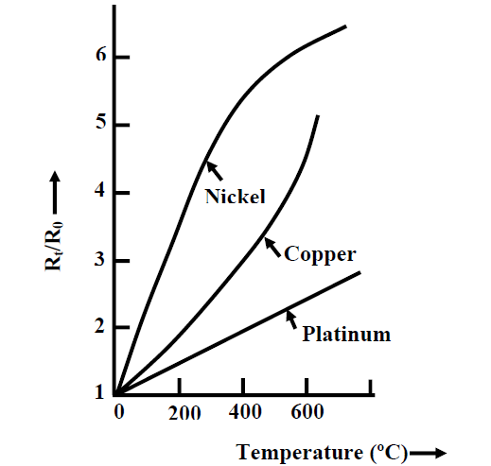

**Fig.2.1. Resistance-temperature characteristics of metals**

Thermistors are semiconductor type resistance thermometers. They have very high sensitivity but highly nonlinear characteristics. This can be understood from the fact that for a typical 2000 Ω the resistance change at 25oC is 80Ω/oC, whereas for a 2000 Ω platinum RTD the change in resistance at 25oC is 7Ω/oC. Thermistors can be of two types: (a) Negative temperature co-efficient (NTC) thermistors and (b) Positive temperature co-efficient (PTC) thermistors. Their resistance-temperature characteristics are shown in fig. 2.2(a) and 2.2.(b) respectively.

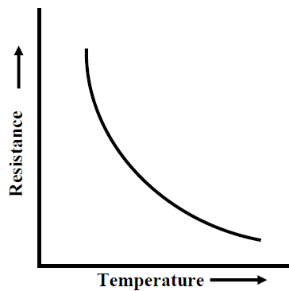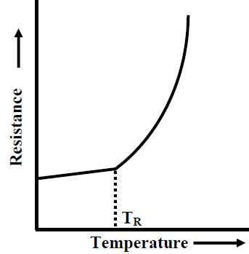

**Fig.2.2(a) NTC thermistor Fig.2.2(b). PTC thermistor**

The NTC thermistors, whose characteristics are shown in fig.2.(a) is more common. Essentially, they are made from oxides of iron, manganese, magnesium etc. The Positive Temperature Coefficient (PTC) thermistor have limited use and they are particularly used for protection of motor and transformer windings. As shown in fig. 2.(b), they have low and relatively constant resistance below a threshold temperature TR, beyond which the resistance increases rapidly. The PTC thermistors are made from compound of barium, lead and strontium titanate.

1. **Thermocouple**

Thomas Johan Seeback discovered in 1821 that thermal energy can produce electric current. When two conductors made from dissimilar metals are connected forming two common junctions and the two junctions are exposed to two different temperatures, a net thermal emf is produced, the actual value being dependent on the materials used and the temperature difference between hot and cold junctions. The thermoelectric emf generated, in fact is due to the combination of two effects: *Peltier effect* and *Thomson effect*.

A typical thermocouple junction is shown in Fig.2.3Thermocouple is a transducer consisting of two different metals welded together at each end; a voltage is produced that is proportional to the difference between in temperature between two junctions where one is maintained at known temperature. The emf generated can be approximately expressed by the relationship:



where T1 and T2 are hot and cold junction temperatures in K. C1 and C2 are constants depending upon the materials.

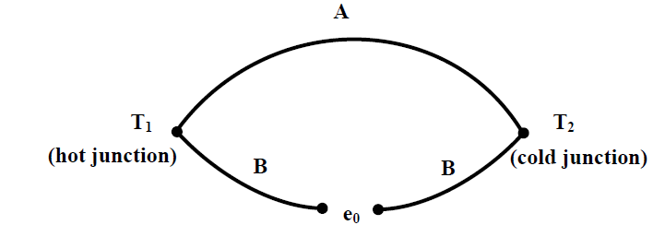

**Fig.2.3. Typical thermocouple**

Thermocouples are extensively used for measurement of temperature in industrial situations. The major reasons behind their popularity are: (i) their readings are consistent, (ii) they can measure over a wide range of temperature, and (iii) their characteristics are almost linear with an accuracy of about 0.05%. However, the major shortcoming of thermocouples is low sensitivity compared to other temperature measuring devices (e.g. RTD, Thermistor).

Theoretically, any pair of dissimilar materials can be used as a thermocouple. But in practice, only few materials have found applications for temperature measurement. The choice of materials is influenced by several factors, namely, sensitivity, stability in calibration, inertness in the operating atmosphere and reproducibility.

**Laws of Thermocouple**

The Peltier and Thompson effects explain the basic principles of thermoelectric emf generation. But they are not sufficient for providing a suitable measuring technique at actual measuring situations. For this purpose, we have three laws of thermoelectric circuits that provide us useful practical tips for measurement of temperature. These laws are known as *law of homogeneous circuit*, *law of intermediate metals* and *law of intermediate temperatures.* These laws can be explained using Fig.2.4.

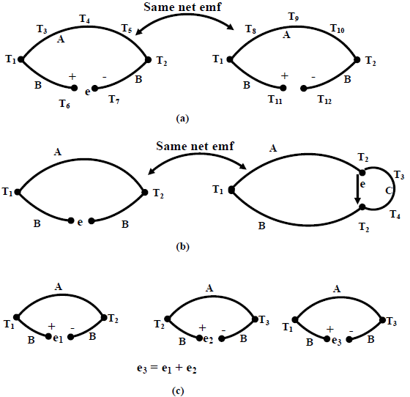

**Fig.2.4. Laws of Thermocouple**

The first law can be explained using Fig.2.4.(a). It says that the net thermo-emf generated is dependent on the materials and the temperatures of two junctions only, not on any intermediate temperature.

According to the second law, if a third material is introduced at any point (thus forming two additional junctions) it will not have any effect, if these two additional junctions remain at the same temperatures (Fig.2.4(b)). This law makes it possible to insert a measuring device without altering the thermo-emf.

The third law is related to the calibration of the thermocouple. It says, if a thermocouple produces emf e1, when its junctions are at T1 and T2, and e2 when its junctions are at T2 and T3; then it will generate emf e1+e2 when the junction temperatures are at T1 and T3 (Fig.2.4(c)).

The third law is particularly important from the point of view of reference junction compensation. The calibration chart of a thermocouple is prepared taking the cold or reference junction temperature as 0oC. But in actual measuring situation, seldom the reference junction temperature is kept at that temperature, it is normally kept at ambient temperature. The third law helps us to compute the actual temperature using the calibration chart. This can be explained from the following example.

**Exercise1**

The following table has been prepared from the calibration chart of *iron-constantan* thermocouple, with reference temperature at 0oC.

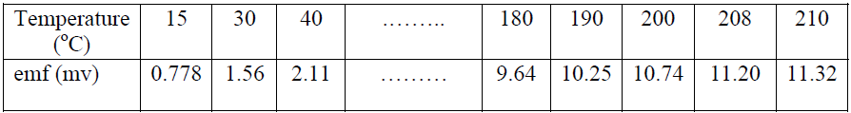

Suppose, the temperature of the hot junction is measured with a *iron-constantan* thermocouple, with the reference junction temperature at 30oC. If the voltage measured is 9.64mv, find the actual temperature of the hot junction.

**Solution**

Referring Fig.2.4(c), for this problem, T3 is the unknown temperature, T2= 30oC, T1= 0oC. The voltages are e2=9.64mv (measured) and e1= 1.56mv (from chart). Therefore, e3= e1+e2= 11.20mv. Hence, from the calibration chart, the actual hot junction temperature is T3 = 208oC.

**Exercise2**

A thermocouple has a linear sensitivity of 30μv/oC, calibrated at a cold junction temperature of 0oC. It is used measure an unknown temperature with the cold junction temperature of 30oC. Find the actual hot junction temperature if the emf generated is 3.0 mv.

**Reference Junction Compensation**

From above discussions, it is imminent that the thermocouple output voltage will vary if the reference junction temperature changes. So, for measurement of temperature, it is desirable that the cold junction of the thermocouple should be maintained at a constant temperature. Ice bath can be used for this purpose, but it is not practical solution for industrial situation. An alternative is to use a thermostatically controlled constant temperature oven. In this case, a fixed voltage must be added to the voltage generated by the thermocouple, to obtain the actual temperature. But the most common case is where the reference junction is placed at ambient temperature.

### 2.1.2 Displacement and Speed Measurement

Displacement and speed are two important parameters whose measurements are important in many position and speed control schemes. Error free measurements of these two parameters are necessary in order to achieve good control performance. Displacement measurement can be of different types. The displacement may be in the range of few μm to few cm. Moreover the measurement may be of contact type or noncontact type. Again displacement to be measured can be linear or angular (rotary). Similar is the case for speed measurement. Accordingly different measuring schemes are used for measurement of these two parameters. In this lesson, we shall discuss about few such schemes.

#### 2.1.2.1 Displacement Measurement

Broadly speaking, displacement measurement can be of two types: contact and noncontact types. Besides the measurement principles can be classified into two categories: **electrical sensing** and **optical sensing**. In electrical sensing, **passive electrical sensors** are used variation of either inductance or capacitance with displacement is measured. On the other hand the optical method mainly works on the principle of intensity variation of light with distance.

##### **Potentiometer**

A **potentiometer** is a three-[terminal](https://en.wikipedia.org/wiki/Terminal_(electronics)) [resistor](https://en.wikipedia.org/wiki/Resistor) with a sliding or rotating contact that forms an adjustable [voltage divider](https://en.wikipedia.org/wiki/Voltage_divider). If only two terminals are used, one end and the wiper, it acts as a **variable resistor** or [**rheostat**](https://en.wikipedia.org/wiki/Potentiometer#Rheostat). The measuring instrument called a [potentiometer](https://en.wikipedia.org/wiki/Potentiometer_(measuring_instrument)) is essentially a [voltage divider](https://en.wikipedia.org/wiki/Voltage_divider) used for measuring [electric potential](https://en.wikipedia.org/wiki/Electric_potential) (voltage).Potentiometers are commonly used to control electrical devices such as volume controls on audio equipment.

The potentiometer is also one of the most commonly used devise for measuring the displacement of the body. The potentiometer is the electrical type of transducer or sensor and it is of resistive type because it works on the principle of change of resistance of the wire with its length. The resistance of the wire is directly proportional to the length of the wire, thus as the length of the wire changes the resistance of the wire also changes. The potentiometer is an electric circuit in which the resistance can be changed manually by the sliding contacts.

Potentiometers are simplest type of displacement sensors. They can be used for linear as well as angular displacement measurement, as shown in Fig.2.6. They are the resistive type of transducers and the output voltage is proportional to the displacement and is given by:



where *xi* is the input displacement, xt is the total displacement and E is the supply voltage.

The major problem with potentiometers is the contact problem resulting out of wear and tear between the moving and the fixed parts. As a result, though simple, application of potentiometers is limited.

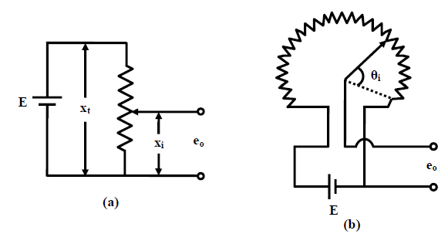

**Fig.2.6. Potentiometer (a) Linear (b) Rotary**

##### **Linear Variable Differential transformer (LVDT)**

LVDT works on the principle of variation of mutual inductance. It is one of the most popular types of displacement sensor. It has good linearity over a wide range of displacement. Moreover the mass of the moving body is small, and the moving body does not make any contact with the static part, thus minimizing the frictional resistance. Commercial LVDTs are available with full scale displacement range of 0.25mm to ±±25mm. Due to the low inertia of the core, the LVDT has a good dynamic characteristics and can be used for time varying displacement measurement range.

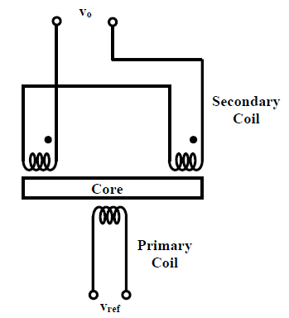

Fig.2.7. **Series opposition connection of secondary windings(LVDT).**

The principle of operation of LVDT can be explained with Fig.2.7. It works on the principle of variation of the mutual inductance between two coils with displacement. It consists of a primary winding and two identical secondary windings of a transformer, wound over a tubular former, and a ferromagnetic core of annealed nickel-iron alloy moves through the former. The two secondary windings are connected in series opposition, so that the net output voltage is the difference between the two. The primary winding is excited by 1-10V r.m.s. A.C. voltage source, the frequency of excitation may be anywhere in the range of 50 Hz to 50 KHz. The output voltage is zero when the core is at central position (voltage induced in both the secondary windings are same, so the difference is zero), but increasing as the core moves away from the central position, in either direction.

Thus, from the measurement of the output voltage only, one cannot predict, the direction of the core movement. A phase sensitive detector (PSD) is a useful circuit to make the measurement direction sensitive. It is connected at the output of the LVDT and compares the phase of the secondary output with the primary signal to judge the direction of movement. The output of the phase sensitive detector after low pass filtering becomes a d.c voltage for a steady deflection.

An LVDT (linear variable differential transformer= is an electromechanical sensor used to convert mechanical motion or vibrations, specifically rectilinear motion, into a variable electrical current, voltage or electric signals,. Physically, the LVDT construction is a hollow metallic cylinder in which a shaft of smaller diameter moves freely back and forth along the cylinder’s long axis.

A linear displacement transducer is an electrical transducer used in measuring linear position. Linear displacement is the movement of an object in one direction along a single axis. Measuring displacement indicates the direction of motion. The output signal of the linear displacement sensor is the measurement of the distance an object has traveled in units of millimeters (mm), or inches (in.), and can have a negative or positive value

##### **Inductive type Sensors**

LVDT works on the principle of variation of mutual inductance. There are inductive sensors for measurement of displacement those are based on the principle of variation of self inductance. These sensors can be used for proximity detection also. Such a typical scheme is shown in Fig.2.8. In this case the inductance of a coil changes as a ferromagnetic object moves close to the magnetic former, thus change the reluctance of the magnetic path. The measuring circuit is usually an a.c. bridge.

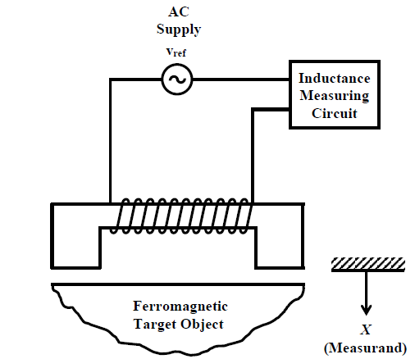

**Self inductance type proximity sensor.**

##### **Rotary Variable Differential Transformer (RVDT)**

Its construction is similar to that of LVDT, except the core is designed in such a way that when it rotates the mutual inductance between the primary and each of the secondary coils changes linearly with the angular displacement. By **definition: Mutual Inductance** between the two coils is defined as the property of the coil due to which it opposes the change of current in the other coil, or you can say in the neighboring coil. When the current in the neighboring coil is changing, the flux sets up in the coil and because of this changing flux emf is induced in the coil called Mutually Induced emf and the phenomenon is known as Mutual Inductance. Schematic diagram of a typical RVDT is shown in Fig.2.9.

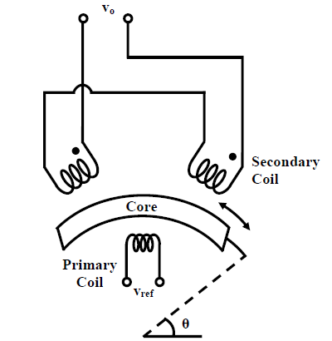

**Fig.2.9. Rotary Variable Differential Transformer (RVDT)**

##### **Capacitance Sensors**

The capacitance type sensor is a versatile one; it is available in different size and shape. It can also measure very small displacement in micrometer range. Often the whole sensor is fabricated in a silicon base and is integrated with the processing circuit to form a small chip. The basic principle of a capacitance sensor is well known. But to understand the various modes of operation, consider the capacitance formed by two parallel plates separated by a dielectric. The capacitance between the plates is given by:



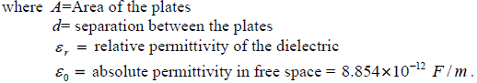

A capacitance sensor can be formed by either varying (i) the separation (*d*), or, (ii) the area (*A*), or (iii) the permittivity (ε*r*). A **displacement type sensor** is normally based on the first two (variable distance and variable area) principles, while the variable permittivity principle is used for **measurement of humidity, level**, etc.

Fig.2.11. Shows the basic constructions of variable gap(distance) and variable area types of capacitance sensors mentioned above. Fig.2.11.(a) shows a variable distance type sensor, where the gap between the fixed and moving plates changes. On the other hand, the area of overlap between the fixed plate and moving plate changes in Fig. 2.11.(b), maintaining the gap constant. The variable area type sensor gives rise to linear variations of capacitance with the input variable, while a variable separation type sensor follows inverse relationship.

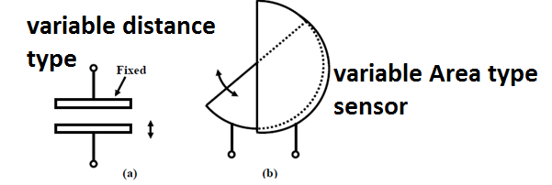

**Fig.2.11. Capacitive type displacement Sensors:**

Capacitance sensors are also used for proximity detection. Such a typical scheme is shown in Fig. 2.12. Capacitive proximity detectors are small in size, noncontact type and can detect presence of metallic or insulating objects in the range of approximately 0-5cm. For detection of insulating objects, the dielectric constant of the insulating object should be much larger than unity. Fig.2.12. shows the construction of a proximity detector. Its measuring head consists of two electrodes, one circular (B) and the other an annular shaped one (A); separated by a small dielectrical spacing. When the target comes in the closed vicinity of the sensor head, the capacitance between the plates A and B would change, which can be measured by comparing with a fixed reference capacitor.

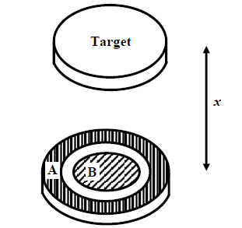

**Fig.2.12. Capacitance Proximity Detector.**

The measuring circuits for capacitance sensors are normally capacitive bridge type. But it should be noted that, the variation of capacitance in a capacitance type sensor is generally very small (few *pF* only, it can be even less than a *pF* in certain cases).

##### **Optical Sensors**

Optical displacement sensors work on the basic principle that the intensity of light decreases with distance. So if the source and detector are fixed, the amount of light reflected from a moving surface will depend on the distance of the moving surface from the fixed ones. Measurement using this principle requires proper calibration since the amount of light received depends upon the reflectivity of the surface, intensity of the source etc.

Optical fibers are often used to transmit light to and from the measuring zone. Such a scheme with bundle fibers is shown in Fig.2.13. It uses two bundle fibers, one for transmitting light from the source and the other to the detector. Light reflected on the receiving fiber bundle by the surface of the target object is carried to a photo detector. The light source could be Laser or LED; photodiodes or phototransistors are used for detection.

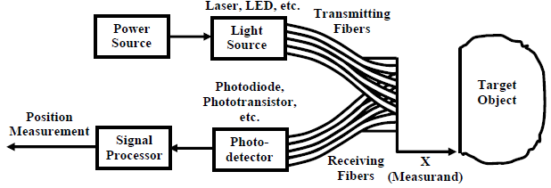

**Fig.2.13. Fiber optic position sensor.**

Displacement/position sensing can be done in three ways. One method is to **convert the displacement signal into voltage and secondly convert displacement into variation of inductance or capacitance and then use suitable measuring circuit to measure their variation. On the other hand, in optical method the intensity of the light reflected from a moving surface** is measured and calibrated in terms of the distance. An important application of displacement measurement is proximity sensing.

#### 2.1.2.2 Speed Measurement

The simplest way for speed measurement of a rotating body is to mount a **tachogenerator** on the shaft and measure the voltage generated by it that is proportional to the speed. However this is a contact type measurement. There are other methods also for noncontact type measurements.

The first method is **an optical method** shown in Fig.2.14. An opaque disc with perforations or transparent windows at regular interval is mounted on the shaft whose speed is to be measured. A LED source is aligned on one side of the disc in such a way that its light can pass through the transparent windows of the disc. As the disc rotates the light will alternately passed through the transparent windows and blocked by the opaque sections. A photo detector fixed on the other side of the disc detects the variation of light and the output of the detector after signal conditioning would be a square wave (as shown) whose frequency is decided by the speed and the number of holes (transparent windows) on the disc.

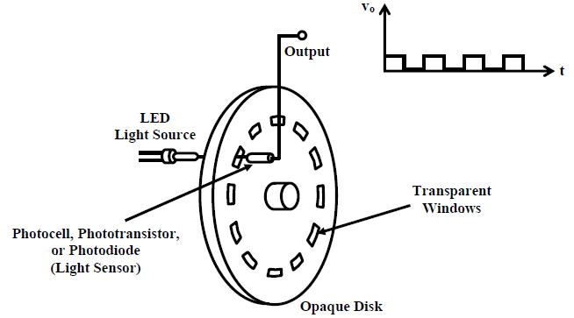

**Fig.2.14. Schematic arrangement of optical speed sensing arrangement.**

The most popular type of speed sensor is the **tachogenerator.** The tachogenerator is mounted on the shaft and the voltage induced that is proportional to the speed is measured. But there are other noncontact methods also in which the speed signal is converted into frequency signal and the frequency is measured.

**Tachogenerator**

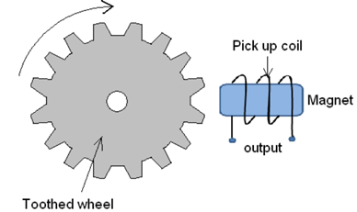

Fig.2.15. **Principle of working of Tachogenerator**

Tachogenerator works on the principle of variable reluctance. It consists of an assembly of a toothed wheel and a magnetic circuit as shown in figure 2.4.1. Toothed wheel is mounted on the shaft or the element of which angular motion is to be measured. Magnetic circuit comprising of a coil wound on a ferromagnetic material core. As the wheel rotates, the air gap between wheel tooth and magnetic core changes which results in cyclic change in flux linked with the coil. The alternating emf generated is the measure of angular motion. A pulse shaping signal conditioner is used to transform the output into a number of pulses which can be counted by a counter.

### 2.1.3 Measurement of Level, Humidity and pH

Level, humidity and pH are three important process parameters and their measurement find wide application in chemical and manufacturing industries. In this chapter we would provide a brief overview of the different techniques adopted for measurement of liquid level and humidity.

#### 2.1.3.1 Level Measurement

There are several instances where we need to monitor the liquid level in vessels. In some cases the problem is simple, we need to monitor the water level of a tank; a simple float type mechanism will suffice. But in some cases, the vessel may be sealed and the liquid a combustible one; as a result, the monitoring process becomes more complex. Depending upon the complexity of the situation, there are different methods for measuring the liquid level, as can be summarized as follows:

(a) Hydrostatic differential pressure gage type

(b) Capacitance type

(c) Ultrasonic type

(d) Radiation technique.

Some of the techniques are elaborated in this section.

* **Hydrostatic Differential Pressure gage**

The hydrostatic pressure developed at the bottom of a tank is given by:

***P=h*ρg** where *h* is the height of the liquid level and ρ is the density of the liquid. So by putting two pressure tapings, one at the bottom and the other at the top of the tank, we can measure the differential pressure, which can be calibrated in terms of the liquid level. Such a schematic arrangement is shown in **Fig.2.16**. However proper care should be taken in the measurement compensate for variation of density of water with temperature and pressure.

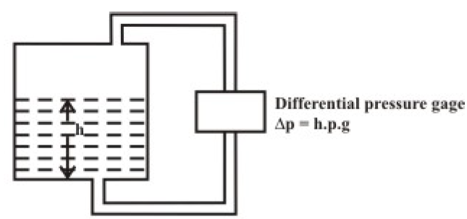 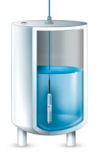

**Fig.2.16. Level measurement using Hydrostatic differential pressure**

* **Capacitance type**

This type of sensors are widely used for chemical and petrochemical industries; and can be used for a wide range of temperature (-40 to 200 oC) and pressure variation (25 to 60 kg/cm2). It uses a coaxial type cylinder, and the capacitance is measured between the inner rod and the outer cylinder, as shown in Fig.2.17. The total capacitance between the two terminals is the sum of (i) capacitance of the insulating bushing, (ii) capacitance due to air and liquid vapour and (iii) capacitance due to the liquid. If the total capacitance measured when the tank is empty is expressed as *C*1, then the capacitance or the liquid level of *h* can be expressed as:



where, **ε1** is the relative permittivity of the liquid and **ε2** is the relative permittivity of the air and liquid vapour . The advantage of capacitance type sensor is that permittivity of the liquid is less sensitive to variation of temperature and can be easily compensated.

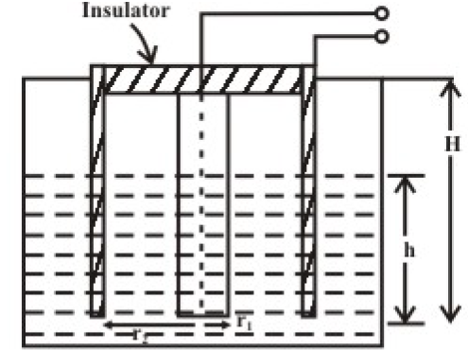

**Fig.2.17. Level measurement using capacitance technique**

* **Ultrasonic type**

Ultrasonic method can be effectively used for measurement of liquid level in a sealed tank. An ultrasonic transmitter/receiver pair is mounted at the bottom of the tank. Ultrasonic wave can pass through the liquid, but gets reflected at the liquid-air interface, as shown in Fig.2.18. The time taken to receive the pulse is measured, that can be related with the liquid level. For accurate measurement, variation of speed of sound with the liquid density (and temperature) should be properly compensated.

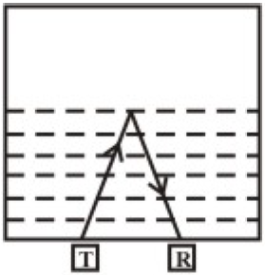

**Fig.2.18. Level measurement using ultrasonic technique**

* **Radiation technique**

Radioactive technique also finds applications in measurement of level in sealed containers. Radioactive ray gets attenuated as it passes through a medium. The intensity of the radiation as it passes a distance *x* through a medium is given by:



where ***Io*** is the incidental intensity and *α* is the absorption co-efficient of the medium. Thus if we measure the intensity of the radiation, knowing ***Io*** , and *α*, *x* can be determined. There are several techniques which are in use. In one method, a float with a radioactive source inside is allowed to move along a vertical path with the liquid level. A Geiger Muller Counter is placed at the bottom of the tank along the vertical path and the intensity is measured. The basic scheme is shown in Fig.2.19(a).

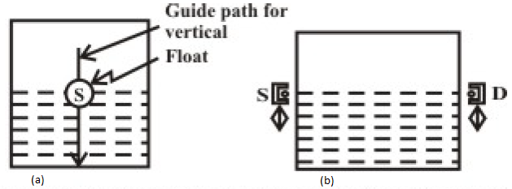

**Fig.2.19. Radiation technique for liquid level measurement**

The method used in a batch filling process of bottles, uses a source-detector assembly that can slide along the two sides of the bottle, as shown in Fig.2.19(b). As soon as the source-detector assembly passes through the liquid-air interface, there would be a large change in the signal received by the detector. Radioactive methods, though simple in principle, find limited applications, because of possible radiation hazards.

#### 2.1.3.2 Humidity Measurement

Humidity measurement finds wide applications in different process industries. Moisture in the atmosphere must be controlled below a certain level in many manufacturing processes, e.g., semiconductor devices, optical fibres etc. Humidity inside an incubator must be controlled at a very precision level. Textiles, papers and cereals must be dried to a standard storage condition in order to prevent the quality deterioration. The humidity can be expressed in different ways: (a) absolute humidity, (b) relative humidity and (c) dew point. Humidity can be measured in different ways. Some of the techniques are explained below.

* **Psychrometer**

Psychrometric method for measurement of relative humidity is a popular method. Two bulbs are used- dry bulb and wet bulb. The wet bulb is soaked in saturated water vapour and the dry bulb is kept in the ambient condition. The temperature difference between the dry bulb and wet bulb is used to obtain the relative humidity through a psychrometric chart. The whole process can also be automated.

* **Conductance/Capacitance method of measurement**

Many solids absorb moisture and their values of the conductance or capacitance change with the degree of moisture absorption. Moisture content in granules changes the capacitance between two electrodes placed inside. By measuring the capacitance variation, the moisture content in the granules can be measured.

* **Infrared Technique**

Water molecule present in any material absorb infrared wave at wavelengths 1.94μm, 2.95 μm and 6.2μm. The degree of absorption of infrared light at any of these wavelengths may provide a measure of moisture content in the material.

### 2.1.4 Optical and Radiation Sensors

This section offers an overview of the basic types of sensors used to detect optical and near-infrared radiation.

#### 2.1.4.1 Photosensors

Light detectors may be broken into two basic categories. The so-called ***quantum detectors*** all convert incoming radiation directly into an electron in a semiconductor device, and process the resulting current with electronic circuitry. The ***thermal detectors*** simply absorb the energy and operate by measuring the change in temperature with a thermometer(<https://www.optris.global/thermal-detector>).

* **Quantum Detectors**

In all of the quantum detectors, the photon is absorbed and an electron is liberated in the structure with the energy of the photon. ***Example: Photodiode***

### The Photodiode.

A photodiode is a semiconductor p-n junction device that converts light into an electrical current. The current is generated when photons are absorbed in the photodiode.

The construction of the **Photodiode** light sensor is similar to that of a conventional PN-junction diode except that the diodes outer casing is either transparent or has a clear lens to focus the light onto the PN junction for increased sensitivity. The junction will respond to light particularly longer wavelengths such as red and infra-red rather than visible light.

The current-voltage characteristic (I/V Curves) of a photodiode with no light on its junction (dark mode) is very similar to a normal signal or rectifying diode. When the photodiode is forward biased, there is an exponential increase in the current, the same as for a normal diode. When a reverse bias is applied, a small reverse saturation current appears which causes an increase of the depletion region, which is the sensitive part of the junction.

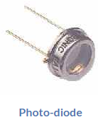 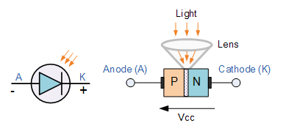

Thus, the photodiodes current is directly proportional to light intensity falling onto the PN-junction. One main advantage of photodiodes when used as light sensors is their fast response to changes in the light levels, but one disadvantage of this type of photodevice is the relatively small current flow even when fully lit(<https://www.teamwavelength.com/photodiode-basics/>).

* **Phototransistor:**

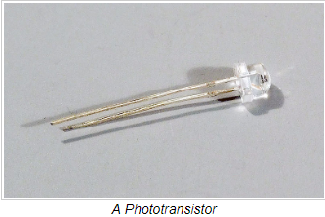

To understand what a phototransistor is, we must first determine what a transistor is.

Basically, a regular transistor is an electrical component that limits the flow of current by a certain amount dependent on current applied to itself through another pin - so there is the collector, emitter, and 'base', which controls how much current can pass through the collector through to the emitter.

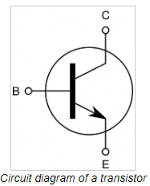

A phototransistor, on the other hand, uses the level of light it detects to determine how much current can pass through the circuit. So, if the sensor is in a dark room, it only lets a small amount of current through. If it detects a bright light, it lets a larger amount of current through.

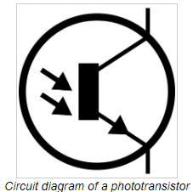 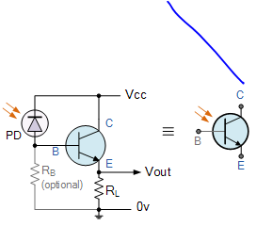

An alternative photo-junction device to the photodiode is the **Phototransistor** which is basically a photodiode with amplification. The Phototransistor light sensor has its collector-base PN-junction reverse biased exposing it to the radiant light source.

* **Photoresistor:**

 A **photoresistor** operates similarly to a phototransistor however it changes its resistance based on the amount of light that falls upon it. Photoresistors tend to be less sensitive,

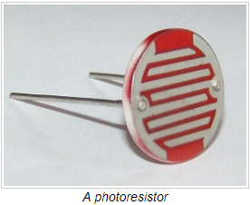 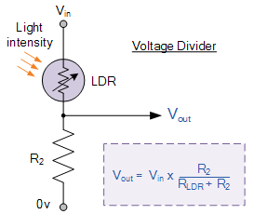

As its name implies, the **Light Dependent Resistor** (LDR) is made from a piece of exposed semiconductor material such as cadmium sulphide that changes its electrical resistance from several thousand Ohms in the dark to only a few hundred Ohms when light falls upon it by creating hole-electron pairs in the material.

# Light Sensor Module Interface With Arduino

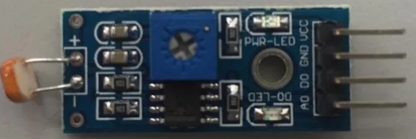

LDR Module

LDR sensor module is used to detect the intensity of light. It is associated with both analog output pin and digital output pin labelled as AO and DO respectively on the board. When there is light, the resistance of LDR will become low according to the intensity of light. The greater the intensity of light, the lower the resistance of LDR. The sensor has a potentiometer knob that can be adjusted to change the sensitivity of LDR towards light.

**Specification:**

* Input Voltage: DC 3.3V to 5V
* Output: Analog and Digital
* Sensitivity adjustable

### 2.1.5 Position and Motion Sensors

As their name implies, position sensors provide position feedback. They are able to perform precise motion control, encoding and counting functions by determining the presence or absence of a target or by detecting its motion, speed, direction or distance.

Position sensors detect a target object, a person, a substance or the disturbance of a magnetic or an electrical field and convert that physical parameter to an electrical output to indicate the target’s position.

There are many ways to sense the position of a target. Some of them, such as limit switches and potentiometers, involve physical contact with the object being sensed.  
These are called contact position sensors. Contact position sensors often prove to be the simplest, lowest cost solution in applications where contact with the target is acceptable.

**a) Types of Position Sensors**

Contact devices:

* Limit switches
* Resistive position transducers

Non-contact devices

* Ultrasonic sensors
* Proximity sensors
* Photoelectric sensors

#### 2.1.5.1Limit Switches

Limit switches are electromechanical contact devices. These are small electrical switches which require physical contact and a small operating force to close the contacts.

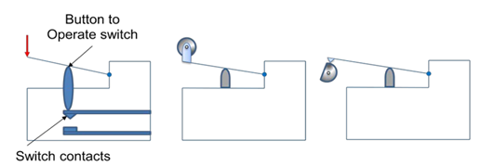

Fig.2.23. **Configurations of contact type proximity switch**

#### 2.1.5.2 Resistive Position Sensors

Potentiometers are passive devices, meaning they require no power supply or additional circuitry to perform their basic linear or rotary position sensing function. They are typically operated in one of two basic modes: **rheostat and voltage divider** (true potentiometric operation). As resistance varies with motion, rheostat applications make use of the varying resistance between a fixed terminal and the sliding contact wiper. In voltage divider applications, a reference voltage signal is applied across the resistive element track so that the voltage “picked up” by the movable contact wiper can be used to determine the wiper’s position.

#### 2.1.5.3 Ultrasonic Position Sensors

Ultrasonic sensors work by exciting an acoustic transducer with voltage pulses, causing the transducer to vibrate ultrasonically. These oscillations are directed at a target and, by measuring the time for the echo to return to the transducer, the target’s distance is calculated.Ultrasonic sensors provide precise no-touch presence/absence sensing and distance sensing or tracking. They are particularly useful where other sensing technologies have difficulty, such as with clear or shiny target objects, foggy or particle-laden air, and environments with splashing liquids. Ultrasonic solutions are often used where larger sensors or longer sensing distances are required.

#### 2.1.5.4 Proximity Sensors

Inductive proximity sensors detect all metal, ferrous metals only, or non-ferrous metals. Capacitive sensors detect all materials.

#### 2.1.5.5 Photoelectric sensors

Photoelectric sensors use an emitter unit to produce a beam of light that is detected by a receiver. When a beam is broken a “presence is detected”.

## 2.2 SIGNAL CONDITIONING CIRCUITS

It has been mentioned in first unit that a basic measurement system consists mainly of the three blocks: **sensing element, signal conditioning element** and **signal processing element**, as shown in Fig.2.22. The sensing element converts the non-electrical signal (e.g. temperature) into electrical signals (e.g. voltage, current, resistance, capacitance etc.). The job of the signal conditioning element is to convert the variation of electrical signal into a voltage level suitable for further processing. The next stage is the signal processing element. It takes the output of the signal conditioning element and converts into a form more suitable for presentation and other uses (display, recording, feedback control etc.). Analog-to-digital converters, linearization circuits etc. fall under the category of signal processing circuits.

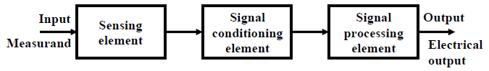

**Fig.22. Elements of a measuring system.**

The success of the design of any measurement system depends heavily on the design and performance of the signal conditioning circuits. Even a costly and accurate transducer may fail to deliver good performance if the signal conditioning circuit is not designed properly.

The schematic arrangement and the selection of the passive and active elements in the circuit heavily influence the overall performance of the system. Often these are decided by the electrical output characteristics of the sensing element. Nowadays, many commercial sensors often have in-built signal conditioning circuit. This arrangement can overcome the problem of incompatibility between the sensing element and the signal conditioning circuit.

If one looks at the different cross section of sensing elements and their signal conditioning circuits, it can be observed that the majority of them use standard blocks like bridges (A.C. and D.C.), amplifiers, filters and phase sensitive detectors for signal conditioning. In this lesson, we would concentrate mostly on bridges and amplifiers and about issues on the design issues.

### 2.2.1 Wheatstone Bridge

These ingenious circuits make use of a null-balance meter to compare two voltages. Unlike the “potentiometer” circuit used to simply measure an unknown voltage, bridge circuits can be used to measure all kinds of electrical values, not the least of which being resistance. In DC measurement circuits, the circuit configuration known as a bridge can be useful way to measure unknown values of resistance.

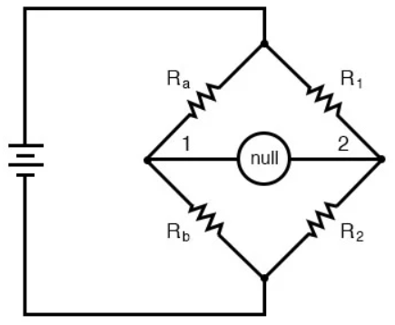

When the voltage between point 1 and the negative side of the battery is equal to the voltage between point 2 and the negative side of the battery, the null detector will indicate zero and the bridge is said to be “balanced.” The bridge’s state of balance is solely dependent on the ratios of Ra/Rb and R1/R2, and is quite independent of the supply voltage (battery).

To measure resistance with a Wheatstone bridge, Any one of the four resistors in the above bridge can be the resistor of unknown value,, while the other three resistors are precision devices of known value. Either of the other three resistors can be replaced or adjusted until the bridge is balanced, and when balance has been reached the unknown [resistor](https://www.allaboutcircuits.com/video-lectures/electronic-components-resistors/) value can be determined from the ratios of the known resistances.

A requirement for this to be a measurement system is to have a set of variable resistors available whose resistances are precisely known, to serve as reference standards. For example, if we connect a bridge circuit to measure an unknown resistance Rx, we will have to know the exact values of the other three resistors at balance to determine the value of Rx:

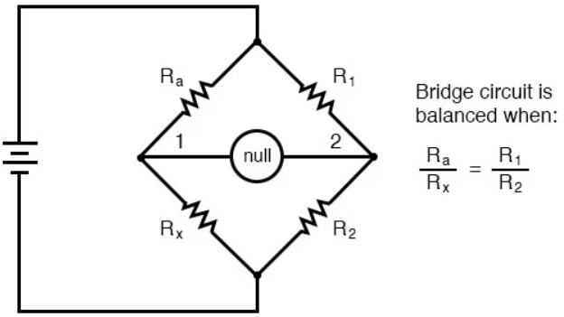

### 2.2.4 Amplifiers

An Amplifier is an integral part of any signal conditioning circuit. However, there are different configurations of amplifiers, and depending of the type of the requirement, one should select the proper configuration.

#### 2.2.4.1 Inverting and Non-inverting Amplifiers

These two types are single ended amplifiers, with one terminal of the input is grounded. From the schematics of these two popular amplifiers, shown in Fig.2.26, the voltage gain for the inverting amplifier is:



while the voltage gain for the non-inverting amplifier is:



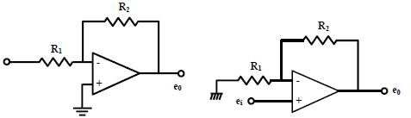

**Fig.2.26. (a) Inverting amplifier, (b) no-inverting amplifier.**

Apparently, both the two amplifiers are capable of delivering any desired voltage gain, provided the phase inversion in the first case is not a problem. But looking carefully into the circuits, one can easily understand, that, the input impedance of the inverting amplifier is finite and is approximately R1 , while a non-inverting amplifier has an infinite input impedance. Definitely, the second amplifier will perform better, if we want that, the amplifier should not load the sensor (or a bridge circuit).

#### 2.2.4.2 Differential Amplifier

Differential amplifiers are useful for the cases, where both the input terminals are floating. These amplifiers find wide applications in instrumentation. A typical differential amplifier with single op.amp. Configuration is shown in Fig.2.27. Then, the output voltage becomes:



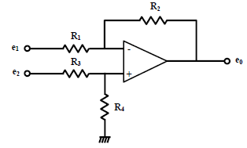

Fig.2.27. **Differential Amplifier**

However, this type of differential amplifier with single op. amp. Configuration also suffers from the limitation of finite input impedance. In fact, several criteria are used for judging the performance of an amplifier. These are mainly: (i) offset and drift, (ii) input impedance, (iii) gain and bandwidth, and (iv) common mode rejection ratio (CMRR). CMRR is a very important parameter for instrumentation circuit applications and it is desirable to use amplifiers of high CMRR when connected to instrumentation circuits.

The CMRR is defined as:



Where Ad, is the differential mode gain and Ac is the common mode gain of the amplifier.

#### 2.2.4.3 Instrumentation Amplifier

Often we need to amplify a small differential voltage few hundred times in instrumentation applications. A single stage differential amplifier, shown in fig.2.27 is not capable of performing this job efficiently, because of several reasons. First of all, the input impedance is finite; moreover, the achievable gain in this single stage amplifier is also limited due to gain bandwidth product limitation as well as limitations due to offset current of the op. amp. Naturally, we need to seek for an improved version of this amplifier.

A three op. amp. Instrumentation amplifier, shown in fig.2.28 is an ideal choice for achieving the objective. The major properties are (i) **high differential gain** (adjustable up to 1000) (ii) **infinite input impedance,** (iii) **large CMRR** (80 dB or more), and (iv) **moderate bandwidth**.

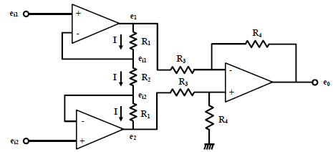

**Fig.2.28. Instrumentation amplifier**

The output for this circuit is given by:



Several issues have to be taken into consideration for the design of a signal conditioning circuit. **Linearity, sensitivity, loading effect, bandwidth, and common mode rejection** are the important issues that affect the performance of the signal conditioning circuits. In this lesson, we have learnt about different configurations of unbalanced D.C. and A.C bridges; those are suitable for resistive, capacitive and inductive type transducers. Besides the characteristics of different types of amplifiers using common operational amplifiers have also been discussed in details. However, the actual design is dependent on the particular sensing element to be used and its characteristics.

# CHAP III: INDUSTRIAL ACTUATORS

Generally, the digital signal from an output channel of a PLC is used to control an actuator which in turn controls some process. The term actuator is used for the device which transforms the electrical signal into some more powerful action which then results in the control of the process. The following are some examples.

## 3.1 Relay

Solenoids form the basis of a number of output control actuators. When a current passes through a solenoid a magnetic field is produced and this can then attract ferrous metal components in its vicinity. One example of such an actuator is the *relay*, the term *contactor* being used when large currents are involved. When the output from the PLC is switched on, the solenoid magnetic field is produced and pulls on the contacts and so closes a switch or switches. The result is that much larger currents can be switched on. Thus the relay might be used to switch on the current to a motor.

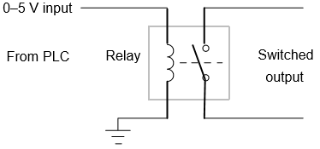

**Fig.3.1. Relay used as an output device**

## 3.2 DC Motor

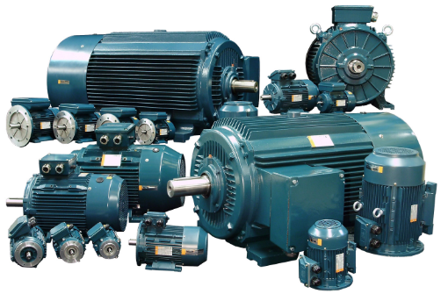

**Fig3.2 DC Motor**

A DC motor is an electromechanical device that converts DC electrical energy into mechanical energy. The principle of operation of any electric motor is based on Ampere’s law, which states the conductor of length *L* will experience a force *F* if an electric current *I* flows through the conductor at right angle to a magnetic filed with a flux density *B*.

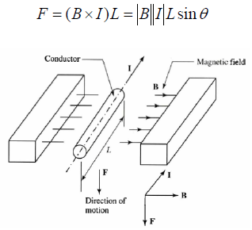

Fig.3.3 **Force acts on a current-carrying conductor in a magnetic field**

where θ is the angle between the current flow and the magnetic flux density. A motor can be constructed from two basic components: one to produce the magnetic field, usually termed the *stato*r, and one to act as the conductor, usually termed *armature* or *rotor*. The stator magnetic may be created either by *field coils* wound on the stator poles or by *permanent magnets* .

A d.c. motor has coils of wire mounted in slots on a cylinder of ferromagnetic material, this being termed the armature. The armature is mounted on bearings and is free to rotate. It is mounted in the magnetic field produced by permanent magnets or current passing through coils of wire, these being termed the field coils. When a current passes through the armature coil, forces act on the coil and result in rotation.

Brushes and a commutator are used to reverse the current through the coil every half rotation and so keep the coil rotating. The speed of rotation can be changed by changing the size of the current to the armature coil. However, because fixed voltage supplies are generally used as the input to the coils, the required variable current is often obtained by an electronic circuit. This can control the average value of the voltage, and hence current, by varying the time for which the constant d.c. voltage is switched on (Fig3.4). The term pulse width modulation (PWM) is used since the width of the voltage pulses is used to control the average d.c. voltage applied to the armature. A PLC might thus control the speed of rotation of a motor by controlling the electronic circuit used to control the width of the voltage pulses.

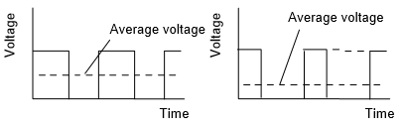

**Fig3.4 Pulse width modulation**

Many industrial processes only require the PLC to switch a d.c. motor on or off. This might be done using a relay. Fig3.5(a) shows the basic principle that the diode is included to dissipate the induced current resulting from the back e.m.f. Sometimes a PLC is required to reverse the direction of rotation of the motor. This can be done using relays to reverse the direction of the current applied to the armature coil. Fig3.5(b) shows the basic principle. For rotation in one direction, switch 1 is closed and switch 2 opened. For rotation in the other direction, switch 1 is opened and switch 2 closed.

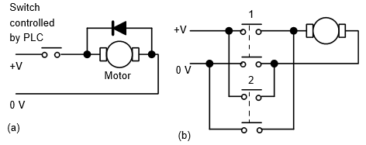

**Fig3.5 d.c. motor: (a) on–off control, (b) directional control**

Another form of d.c. motor is the brushless d.c. motor. This uses a permanent magnet for the magnetic field but, instead of the armature coil rotating as a result of the magnetic field of the magnet, the permanent magnet rotates within the stationary coil. With the conventional d.c. motor, a commutator has to be used to reverse the current through the coil every half rotation in order to keep the coil rotating in the same direction. With the brushless permanent magnet motor, electronic circuitry is used to reverse the current. The motor can be started and stopped by controlling the current to the stationary coil. To reverse the motor, reversing the current is not so easy because of the electronic circuitry used for the commutator function. One method that is used is to incorporate sensors with the motor to detect the position of the north and south poles. These sensors can then cause the current to the coils to be switched at just the right moment to reverse the forces applied to the magnet. The speed of rotation can be controlled using pulse width modulation, i.e. controlling the average value of pulses of a constant d.c. voltage.

## 3.3 Stepper Motor

The stepper or stepping motor is a motor that produces rotation through equal angles, the so-termed steps, for each digital pulse supplied to its input. Thus, if one input pulse produces a rotation of 1.8o then 20 such pulses would give a rotation of 36.0o. To obtain one complete revolution through 360o, 200 digital pulses would be required. The motor can thus be used for accurate angular positioning.

If it is used to drive a continuous belt, it can be used to give accurate linear positioning. Such a motor is used with computer printers, robots, machine tools and a wide range of instruments where accurate positioning is required. There are two basic forms of stepper motor, **the permanent magnet type with a permanent magnet rotor** and the **variable reluctance type** with a soft steel rotor. Fig3.6 shows the basic elements of the permanent magnet type with two pairs of stator poles.

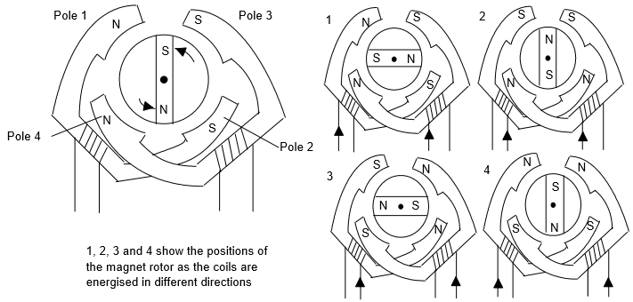

Fig.6 The Operation principles of the permanent magnet stepper motor (2-phase) with 90o steps

Each pole is activated by a current being passed through the appropriate field winding, the coils being such that opposite poles are produced on opposite coils. The current is supplied from a d.c. source to the windings through switches. With the currents switched through the coils such that the poles are as shown in Fig3.6, the rotor will move to line up with the next pair of poles and stop there.

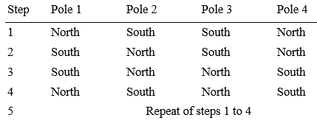

Stepper motor, electromechanical construction is such that it moves in discrete mechanical steps. A change in phase current from one state to another creates a single step change in the rotor position. If the phase current state is not changed, the rotor position stays in that stable position

The operating principle of a basic stepper motor is shown schematically in Fig3.7 , in which the rotor has one north and one south pole permanent magnet; and the stator has four-pole, two-phase winding with four switches. At any given time either switch 1 or 2, and 3 or 4 can be ON to affect the polarity of electromagnets. For each state, there is a corresponding stable rotor position.

At any given time, all of the stator phases are energized; and each rotor pole is attracted by two winding poles. Following the four switching sequence, the rotor would take the shown stable positions. The type of phase current switch, where both phases are energized, is referred to as “full-step” model of operation.

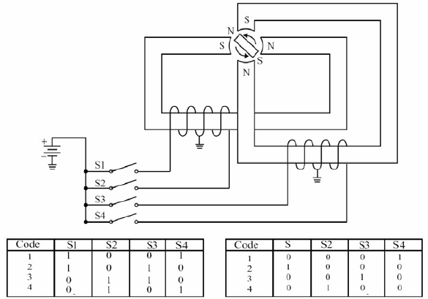

Fig3.7 Operating principles of a stepper motor

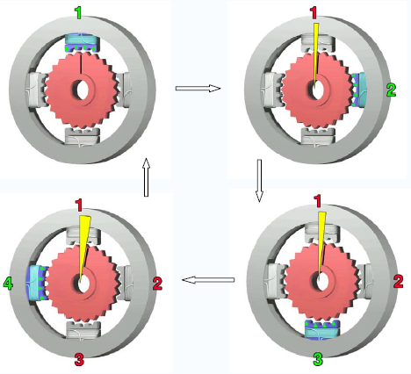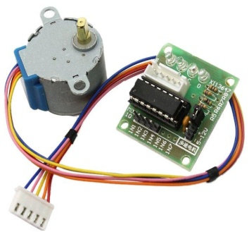

**Fig3.8 Stepper motor rotating a small angel in each step**

To make the motor shaft turn, first one electromagnet is given power, which makes the gear's teeth magnetically attracted to the electromagnet's teeth. When the gear's teeth are thus aligned to the first electromagnet, they are slightly offset from the next electromagnet. When the next electromagnet is turned on and the first is turned off, the gear rotates slightly to align with the next one, and from there the process is repeated. Each of those slight rotations is called a "step." In that way, the motor can be turned at precise angle.

## 3.4 Pneumatic and Hydraulic Actuators

**Pneumatics** is a branch of engineering that makes use of gas or pressurized air to perform some works. Pneumatic actuators enable considerable forces to be produced from relatively small pressure changes. A pneumatic actuator converts energy formed by vacuum or compressed air at high pressure into either linear or rotary motion.

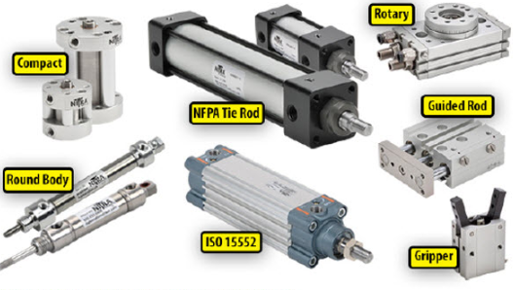

**Fig3.9 Pneumatic Actuators**

**Hydraulic Actuators,** as used in industrial process control, employ hydraulic pressure to drive an output member. Hydraulic actuators convert fluid pressure into motion. Similar to pneumatic actuators, they are used on linear or quarter-turn valves. These are used where high speed and large forces are required. The fluid used in hydraulic actuator is highly incompressible so that pressure applied can be transmitted instantaneously to the member attached to it

## 3.4.1 Directional Control Valves

Another example of the use of a solenoid as an actuator is a solenoid operated valve. The valve may be used to control the directions of flow of pressurized air or oil and so used to operate other devices such as a piston moving in a cylinder. Fig 3.10 shows one such form, a spool valve, used to control the movement of a piston in a cylinder. Pressurized air or hydraulic fluid is inputted from port P, this being connected to the pressure supply from a pump or compressor and port T is connected to allow hydraulic fluid to return to the supply tank or, in the case of a pneumatic system, to vent the air to the atmosphere.

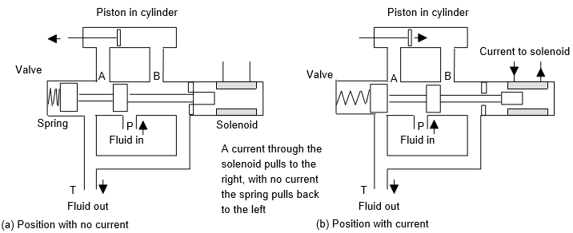

**Fig.3.10 A solenoid operated valve**

With no current through the solenoid (Fig 3.10(a)) the hydraulic fluid or pressurized air is fed to the right of the piston and exhausted from the left, the result then being the movement of the piston to the left. When a current is passed through the solenoid, the spool valve switches the hydraulic fluid or pressurized air to the left of the piston and exhausted from the right. The piston then moves to the right. The movement of the piston might be used to push a deflector to deflect items off a conveyor belt or implement some other form of displacement which requires power.

With the above valve there are the two control positions shown in Fig.3.10(a) and (b). Directional control valves are described by the number of ports they have and the number of control positions. The valve shown in Fig3.10 has four ports, i.e. A, B, P and T, and two control positions. It is thus referred to as a 4/2 valve. The basic symbol used on drawings for valves is a square, with one square being used to describe each of the control positions. Thus the symbol for the valve in Fig3.10 consists of two squares (Fig3.10 (a)). Within each square the switching positions are then described by arrows to indicate a flow direction or a terminated line to indicate no flow path. Fig3.11(b) shows this for the valve shown in Fig3.10.

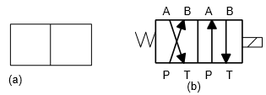

**Fig3.11 (a) Symbol for a two position valve, (b) the 4/2 valve**

Direction valves can be used to control the direction of motion of pistons in cylinders, the displacement of the pistons being used to implement the required actions. The term **single acting cylinder** (Fig3.12(a)) is used for one that is powered by the pressurized fluid being applied to one side of the piston to give motion in one direction, it being returned in the other direction by possibly an internal spring. The term **double acting cylinder** (Fig3.12 (b)) is used when the cylinder is powered by fluid for its motion in both piston movement directions.

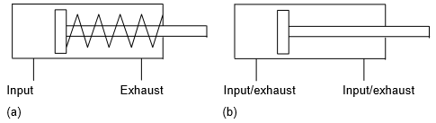

**Fig3.12 Cylinders: (a) single acting, (b) double acting**

Fig3.13 shows how a valve can be used to control the direction of motion of a piston in a single-acting cylinder; Fig3.14 shows how two valves can be used to control the action of a piston in a double acting cylinder.

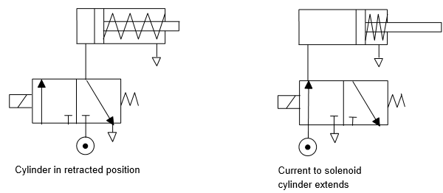

**Fig3.13 Control of a single-acting cylinder**

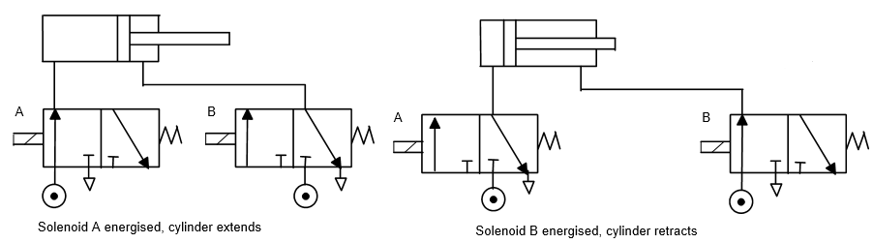

**Fig3.14 Control of a double-acting cylinder**

## 3.5 ACTUATORS APPLICATIONS

### 3.5.1 A conveyor belt

Consider a conveyor belt that is to be used to transport goods from a loading machine to a packaging area (Fig3.15). When an item is loaded onto the conveyor belt, a contact switch might be used to indicate that the item is on the belt and start the conveyor motor. The motor then has to keep running until the item reaches the far end of the conveyor and falls off into the packaging area. When it does this, a switch might be activated which has the effect of switching off the conveyor motor. The motor is then to remain off until the next item is loaded onto the belt. Thus the inputs to a PLC controlling the conveyor are from two switches and the output is to a motor.

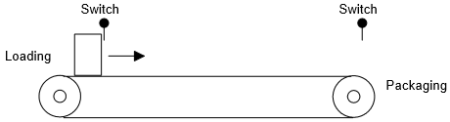

**Fig3.15 Conveyor**

### 3.5.2 A robot control system

Fig3.16. shows how directional control valve can be used for a control system of a robot. When there is an input to solenoid A of valve 1, the piston moves to the right and causes the gripper to close. If solenoid B is energized, with A de-energized, the piston moves to the left and the gripper opens. When both solenoids are de-energized, no air passes to either side of the piston in the cylinder and the piston keeps its position without change.

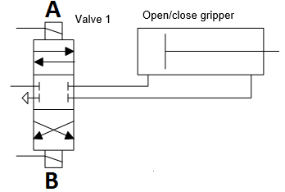

**Fig3.16 Robot Controls**

# CHAP IV: PROGRAMMABLE LOGIC CONTROL SYSTEMS

## 4.0 Introduction

Control engineering has evolved over time. In the past humans were the main methods for controlling a system. More recently electricity has been used for control and early electrical control was based on relays. These relays allow power to be switched on and off without a mechanical switch. It is common to use relays to make simple logical control decisions. With the development of low cost computer has brought the most recent revolution, the Programmable Logical Controller(PLC). The advent of the PLC began in the 1970s and has become the most common choice for manufacturing controls.

## 4.1 Sequence and Logic Control

Many control applications do not involve analog process variables, the ones which can assume a continuous range of values, but instead variables that are set valued, that is they only assume values belonging to a finite set. The simplest examples of such variables are binary variables, that can have either of two possible values, (such as 1 or 0, on or off, open or closed etc.). These control systems operate by turning on and off switches, motors, valves, and other devices in response to operating conditions and as a function of time. Such systems are referred to as **sequence/logic control systems**. For example, in the operation of transfer lines and automated assembly machines, sequence control are used to coordinate the various actions of the production system (e.g., transfer of parts, changing of the tool, feeding of the metal cutting tool, etc.).

## 4.2. Discrete Sensors and Actuators

There are many industrial sensors which provide discrete outputs which may be interpreted as the presence/absence of an object in close proximity, passing of parts on a conveyor, For example, tables below show a set of typical sensors which provide a discrete set of output corresponding to process variables.

|  |  |  |
| --- | --- | --- |
| **TYPE** | **Signal** | **Remark** |
| Switch | Binary, Command | External Input device |
| Limit Switch | Position | Feedback Sensor device |
| Thermostat | Temperature Level | Feedback Sensor device |
| Photo Cell | Position of objects | Feedback Sensor device |
| Proximity detector | Position of objects | Feedback Sensor device |
| Push button | Command | External Input device |

**Table1. Discrete Sensors**

* **Example Industrial Discrete Output and Actuation Devices**

|  |  |  |
| --- | --- | --- |
| **Type** | **Output Quantity** | **Energy Source** |
| Relay, Contact | Voltage | electrical |
| Motor Starter | motion | electrical |
| Lamp | indication | electrical |
| Solenoid | motion | electrical |
| On-off Flow Control valve | flow | pneumatic |
| Directional Valves | Hydraulic Pressure | pneumatic, hydraulic |

**Table2. Industrial Discrete Output and Actuation Devices**

## PROGRAMMABLE LOGIC CONTROLLERS (PLC)

### Introduction

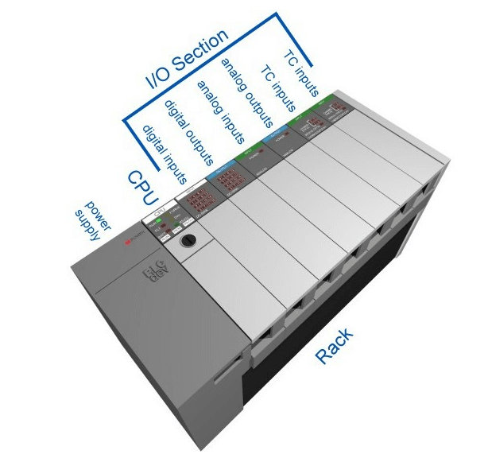

A modern controller device used extensively for sequence control today in transfer lines, robotics, process control, and many other automated systems is the **Programmable Logic Controller** (PLC). In essence, a PLC is a special purpose industrial microprocessor based real-time computing system, which performs the following functions in the context of industrial operations.

* Monitor Input/Sensors
* Execute logic, sequencing, timing, counting functions for Control/Diagnostics
* Drives Actuators/Indicators

A programmable logic controller (PLC) is a special form of microprocessor-based controller that uses a programmable memory to store instructions and to implement functions such as logic, sequencing, timing, counting and arithmetic in order to control machines and processes and are designed to be operated by engineers with perhaps a limited knowledge of computers and computing language Communicates with other computers. The term logic is used because programming is primarily concerned with implementing logic and switching operations, e.g. if A or B occurs switch on C, if A and B occurs switch on D.

Input devices, e.g. sensors such as switches, and output devices in the system being controlled, e.g. motors, valves, etc., are connected to the PLC. The operator then enters a sequence of instructions, i.e. a program, into the memory of the PLC. The controller then monitors the inputs and outputs according to this program and carries out the control rules for which it has been programmed.

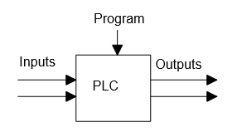

Fig.4.1. programmable logic controller

PLCs are similar to computers but whereas computers are optimized for calculation and display tasks, PLCs are optimized for control tasks and the industrial environment..A PLC is a computer specially designed to operate reliably under harsh industrial environments – such as extreme temperatures, wet, dry, and/or dusty conditions. It is used to automate industrial processes such as a manufacturing plant’s assembly line, an ore processing plant, or a wastewater treatment plant.

PLCs share many features of the personal computer you have at home. They both have a power supply, a CPU (Central Processing Unit), inputs and outputs (I/O), memory, and operating software (although it’s a different operating software). The biggest differences are that a PLC can perform discrete and continuous functions which a PC cannot do, and a PLC is much better suited to rough industrial environments. A PLC can be thought of as a ‘ruggedized’ digital computer which manages the electromechanical processes of an industrial environment.

PLCs plays a crucial role in the field of automation, using forming part of a larger [SCADA system](https://www.electrical4u.com/scada-system/). A PLC can be programmed according to the operational requirement of the process. In the manufacturing industry, there will be a need for reprogramming due to the change in the nature of production.

### 4.3.2 SCADA Control System

SCADA stands for “**Supervisory Control and Data Acquisition**”. SCADA is a type of process [control system](https://www.electrical4u.com/control-system-closed-loop-open-loop-control-system/) architecture that uses computers, networked data communications and graphical Human Machine Interfaces (HMIs) to enable a high-level process supervisory management and control. SCADA systems communicate with other devices such as [programmable logic controllers](https://www.electrical4u.com/programmable-logic-controllers/) (PLCs) and [PID controllers](https://www.electrical4u.com/pid-control/) to interact with industrial process plant and equipment.

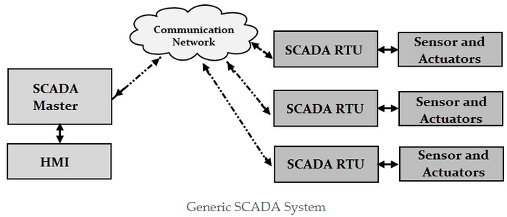

**Fig.4.2 (a). SCADA System**

SCADA systems form a large part of [control systems engineering](https://www.electrical4u.com/control-engineering-historical-review-and-types-of-control-engineering/). SCADA systems gather pieces of information and data from a process that is analyzed in real-time . It records and logs the data, as well as representing the collected data on various HMIs. This enables process control operators to supervise what is going on in the field, even from a distant location. It also enables operators to control these processes by interacting with the HMI.

SCADA systems are essential to a wide range of industries and are broadly used for the controlling and monitoring of a process. SCADA systems are prominently used as they have the power to control, monitor, and transmit data in a smart and seamless way. In today’s data-driven world, we are always looking for ways to increase automation and make smarter decisions through the proper use of data – and SCADA systems are a great way of achieving this.

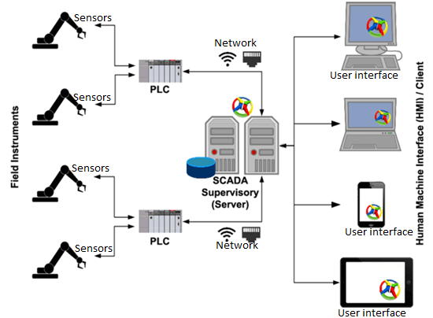

**Fig.4.2(b). SCADA System**

SCADA systems can be run virtually, which allows the operator to keep a track of the entire process from his place or control room. Time can be saved by using SCADA efficiently. One such excellent example is, SCADA systems are used extensively in the Oil and Gas sector. Large pipelines will be used to transfer oil and chemicals inside the manufacturing unit. Hence, safety plays a crucial role, such that there should not be any leakage along the pipeline. In case, if some leakage occurs, a SCADA system is used to identify the leakage. It infers the information, transmits it to the system, displays the information on the computer screen and also gives an alert to the operator.

### 4.3.3 EVOLUTION OF PLC

Before the advent of microprocessors, industrial logic and sequence control used to be performed using elaborated control panels containing electromechanical or solid-state relays, contactors and switches, indicator lamps, mechanical or electronic timers and counters etc., all hardwired by complex and elaborate wiring. In fact, for many applications such control panels are used even today. However, the development of microprocessors in the early 1980’s quickly led to the development of the PLCs.

### 4.3.4 PLC ADVANTAGES OVER CONTROL PANNELS

* Programming the PLC is easier than wiring physical components; the only wiring required is that of connecting the I/O terminals.
* The PLC can be reprogrammed using user-friendly programming devices. Controls must be physically rewired.
* PLCs take up much less space.
* Installation and maintenance of PLCs is easier, and with present day solid-state technology, reliability is greater.
* The PLC can be connected to a distributed plant automation system, supervised and monitored.
* Beyond a certain size and complexity of the process, a PLC-based system compare favorably with control panels.

Imagine you have a light connected to a switch. In general, the light operates under two conditions – ON and OFF. Now you are given a task that when you turn ON the switch, the light should glow only after 30 seconds. With this hard-wired setup – we’re stuck. The only way to achieve this is to completely rewire our circuit to add a timing relay. That’s a lot of hassle for a minor change.

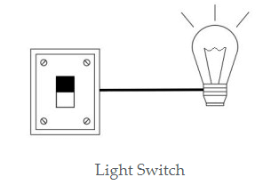

**Fig.4.3. Light Switch**

This is where a PLC comes into the picture, which doesn’t require any additional wiring and hardware to make sure a change. Rather it requires a simply change in code, programming the PLC to only turn on the light 30 seconds after the switch is turned ON. So, by using a PLC, it is easy to incorporate multiple inputs and outputs. This is just a simple example – a PLC has the ability to control much larger and more complex processes. A PLC can be customized depending on the application and needs of the user.

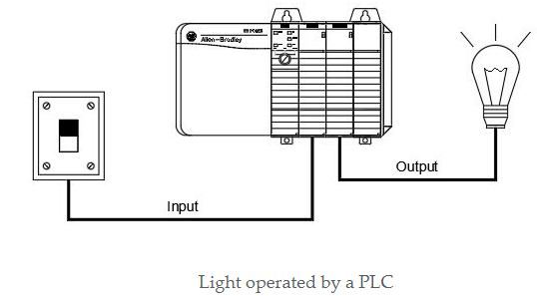

**Fig.4.4. Light Operated Switch**

### 4.3.5 Application Areas

PLCs have a variety of applications and uses, including:

* Logic/Sequence control
* PID control and computing
* Process Automation Plants (e.g. mining, oil &gas)
* Glass Industry
* Paper Industry
* Cement Manufacturing
* In boilers – Thermal Power Plant

Any manufacturing application that involves controlling repetitive, discrete operations is a potential candidate for PLC usage, e.g. machine tools, automatic assembly equipment, molding and extrusion machinery, textile machinery and automatic test equipment.

### 4.3.6 TYPES OF PLCs

The two main types of PLC are fixed.

### Compact PLC

Within a single case, there would be many modules. It has a fixed number of I/O modules and external I/O cards. So, it does not have the capability to expand the modules. Every input and output would be decided by the manufacturer.

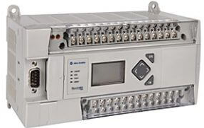

**Fig.4.4. Compact PLC**

The compact PLC don’t have the capability to expand the modules as it has fixed number of I/O module and external I/O card.

### Modular PLC

This type of PLC permits multiple expansion through “modules”, hence referred to as Modular PLC. I/O components can be increased. It is easier to use because each component is independent of each other

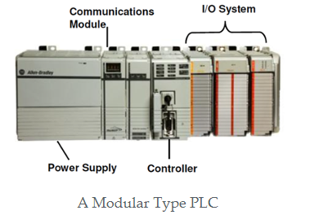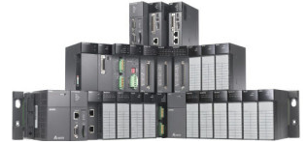

**Fig.4.6. Modular type PLC**

In modular type PLC, the number of I/Os can be increased by the addition of modules to the existing PLC.

PLC are divided into three types based on output namely **Relay output, Transistor output, and Triac Output PLC**. The relay output type is best suited for both AC and DC output devices. Transistor output type PLC uses switching operations and used inside microprocessors. And according to the physical size, a PLC is divided into Mini, Micro and Nano PLC.

Some of the manufacturers of PLCs include:

* [Allen Bradley](https://ab.rockwellautomation.com/Programmable-Controllers/ControlLogix/5580-Controllers)
* [ABB](https://new.abb.com/plc/programmable-logic-controllers-plcs)
* [Siemens](https://new.siemens.com/global/en/products/automation/systems/industrial/plc.html)
* [Mitsubishi PLC](https://www.mitsubishielectric.com/fa/products/cnt/plc/index.html)
* [Hitachi PLC](https://www.hitachi-ies.co.jp/english/products/plc/index.htm)
* [Delta PLC](https://www.deltaww.com/Products/CategoryListT1.aspx?CID=060301&PID=ALL&hl=en-US)
* [General Electric (GE) PLC](http://www.geautomation.com/products/programmable-automation-controllers%EF%BB%BF)
* [Honeywell PLC](https://www.honeywellprocess.com/en-US/explore/products/control-monitoring-and-safety-systems/scalable-control-solutions/Pages/masterlogic-plc.aspx)

### 4.3.7 PLC Hardware

Typically a PLC system has the basic functional components of processor unit, memory, power supply unit, input/output interface section, communications interface and the programming device. The PLC is essentially a microprocessor-based real-time computing system that often has to handle significant I/O and Communication activities, bit oriented computing, as well as normal floating point arithmetic. A typical set of components that make a PLC System is shown in Fig.4.7. below.

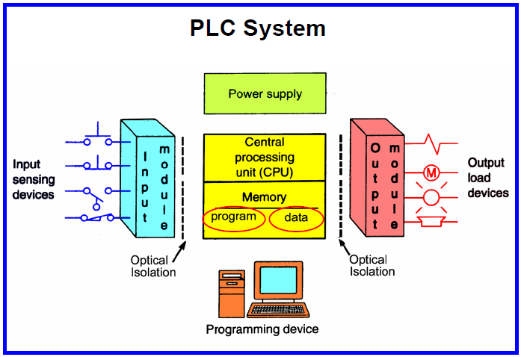

**Fig.4.7(a). PLC System Architecture**

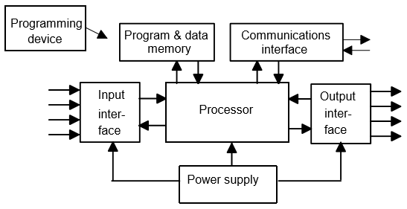

Fig.4.7 (b). **PLC System Architecture**

### 4.3.8. CPU Module

The processor unit or central processing unit (CPU) is the unit containing the microprocessor and this interprets the input signals and carries out the control actions, according to the program stored in its memory, communicating the decisions as action signals to the outputs. This is the main computing module where ladder logic and other application programs are stored and processed. The processor also consists of serial communication ports for printer, PLC LAN link and also external programming devices.

### 4.3.9. Power supply:

The power supply given to a particular PLC depends upon the Manufacturers specifications. A power supply may be inbuilt processor module or a separate module. Common voltage levels required by the PLC are 24Vdc, 120Vac, 220Vac.

### 4.3.10 Memory Module

The memory unit is where the program is stored that is to be used for the control actions to be exercised by the microprocessor and data stored from the input for processing and for the output for outputting.

### 4.3.10. Programming Unit:

Programming Unit allows the engineer to enter and edit the program to be executed. More advanced systems employ a personal computer which enables the programmer to write, view and edit the program and download it to the PLC. This is accomplished using licensed software provided by the manufacturer. The software allows the programmer to simulate the program in real time scenario to determine proper operation. It also allows easy debugging of the program.

### 4.3.11. Indicator lights

These indicate the status of the PLC including power on, program running, and a fault. These are essential when diagnosing problems.

### 4.3.12. Input and output modules:

A number of input/output modules must be provided so that the PLC can monitor the process and initiate control actions as specified in the application control programs. Depending on the size of the PLC systems the input-output subsystem can either span across several cards or even be integrated on the processor module.

Input and output modules are specified according to the requirements of a particular application. I/O can be either discrete, analog. Discrete I/O modules are capable of handling ON-OFF type inputs or outputs per module. Analog I/O modules are specified according to desired resolution and voltage or current range. Pulsed inputs to the PLC are accepted through a high speed counter.

1. **Input/Module**

The inputs might thus be from switches, or other sensors such as photo-electric cells, temperature sensors, or flow sensors, etc. Input modules convert process level signals from sensors (e.g. voltage face Contacts, 0-24v Dc, 4 – 20mA), to processor level digital signals such as 5V or 3.3 V.

1. **Analog input modules**

Analog input modules convert analog process level signals to digital values, which are then processed by the digital electronic hardware of the programmable controller. The analog modules sense analog signals in the range ± 5 V, ± 10 V or 0 to 10 V.

An analog module typically contains:

* Analog to digital (A/D) converters

1. **Digital Input Modules**

The digital inputs modules convert the external binary signals from the process to the internal digital signal level of programmable controllers. Digital input channel processing involves isolation and signal conditioning before inputting to a comparator for conversion to a 0 or a 1.

1. **Output Modules**

Outputs to actuators allow a PLC to cause something to happen in a process. The outputs from these modules may be used to drive actuators. Consequently, they include circuitry for current / power drive using solid-state electronics such as transistors for DC outputs or triacs for AC outputs. Continuous outputs require output cards with D/A converters. Sometimes they also provide potential free relay contacts (NO/NC), which may be used to drive higher power actuators using a separate power source. Since these modules straddle across the processor and the output power circuit, these must provide isolation. External power supplies are connected to the output card and the card will switch the power on or off for each output. Typical output voltages are 120V ac, 24V dc, 12-48V ac/dc, 5V dc (TTL) or 230V ac. **There are three main types of output module:**

**Relay (volt-free):** The signal from the PLC operates a relay within the output module connecting the control voltage to the output port and hence to the actuator.

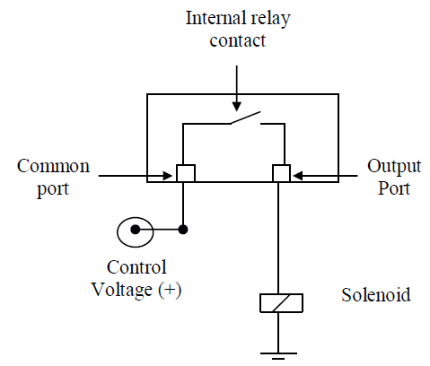

**Fig.4.2. PLC Relay output**

**Transistor**: A transistor is used to switch on the output. This is faster than a relay output but is only suitable for low power direct current applications.

**Triac**: This solid state device is used for switching alternating current devices. It requires some form of over current protection.

* **Analog Output Module**

Analog output modules convert digital values from the PLC processor module into an analog signal required by the process. These modules therefore require a D/A converter for providing analog outputs. However, typically, servo-amplifiers for power amplification, required for driving high current loads directly, are not integrated on-board.

* **Digital Output Module**

Digital output modules convert internal signal levels of the programmable controllers into the binary signal levels required externally by the process.

1. **Function Modules**

For high speed i/o tasks such as one required to measure speed by counting pulses from shaft angle encoders, or for precision position control applications, independent i/o modules that execute tasks independently of the central processor are required to meet the timing requirements of the i/o. The signal preprocessing “intelligent” I/O- modules make it possible to count fast impulse trains, to acquire and process travel increments, speed and time measure etc., i.e. they take on the critical timing control tasks which normally can’t be carried out fast enough by the central processor with its programmable logic control, as well as its primary logic control functions.

These modules not only relieve the central processor of additional tasks, they also provide fast and specialized solutions to some common control problems. The processing of the signals is carried out primarily by the appropriate I/O- modules, which frequently operate with their own processor. Below we discuss two such modules, which are used with PLCs to handle specific high performance automation functions.

1. **Count Module**

Itis employed where pulses at high frequency have to be counted, i.e. when machines run fast. It can also be applied to output fast pulse trains or realize accurate timing signals. A count module senses fast pulses, from sources such as shaft angle encoders, through several input ports. Counting frequency can be as high as 2 MHz and a typically, a counter of length 16 bit or more can count up and down. Counter modules can often also be applied for time and frequency measurement and as a frequency divider. Typical counter module hardware contains, among possible other things, an interface to the processor through the system bus, a counter electronics block, a quartz controlled frequency generator and a frequency divider.

For each counter there are a number of different operating modes, which can be set by a user program. With a comparator and an alarm register, a number of count values can be compared and under defined conditions configured to turn on a process alarm.

1. **A Loop Controller Module**

A loop controller module is suitable for solving fast control loop problems. A typical module can process several control loops with sampling times varying between a few milliseconds to several seconds. The process output values are measured via analog input ports and are compared with the set point values. The power circuits of the actuator units are driven through analog output ports. Such a module contains a microprocessor, which controls the sensing and processing of the process output and set point values and computes the control law and outputs the manipulated variables. The operating configurations of the loop controller module are assigned with a programmer .The central controller provides set point values, parameters and control commands and reads the output values.

The application software for the module can be structured in terms of standard close loop functions (e.g. ramp function generator, speed controller, etc.). These standard functions can be interconnected to a closed loop structures with the aid of a programmer interface and are the resulting control code automatically compiled and downloaded to memory on the module. The microprocessor executes the standard functions in accordance with the designed closed loop structure for an application such as a motor drive or a standard cascade process control loop.

### 4.3.13. Communication Interface

The communications interface is used to receive and transmit data on communication networks from or to other remote PLCs (Figure 4.8). It is concerned with such actions as device verification, data acquisition, synchronization between user applications and connection management.

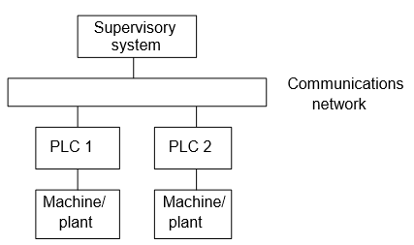

Fig.4.8. PLC Communication model

## PLC Internal architecture

The basic internal architecture of a PLC consists of a central processing unit (CPU) containing the system microprocessor, memory, and input/output circuitry. The CPU controls and processes all the operations within the PLC. It is supplied with a clock with a frequency of typically between 1 and 8 MHz. This frequency determines the operating speed of the PLC and provides the timing and synchronization for all elements in the system. The information within the PLC is carried by means of digital signals. The internal paths along which digital signals flow are called buses. In the physical sense, a bus is just a number of conductors along which electrical signals can flow.

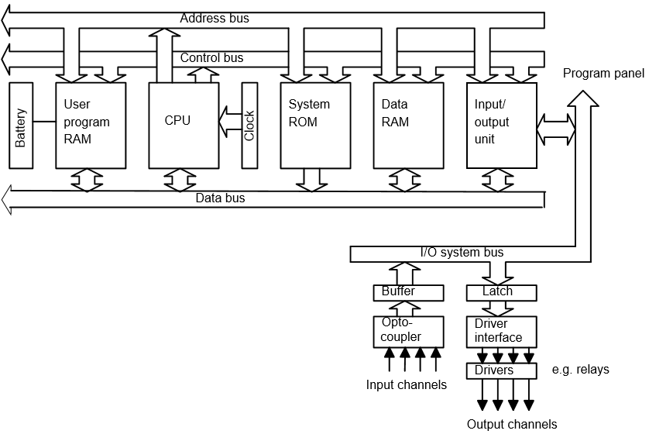

The CPU uses the data bus for sending data between the constituent elements, the address bus to send the addresses of locations for accessing stored data and the control bus for signals relating to internal control actions. The system bus is used for communications between the input/output ports and the input/output unit.

The internal structure of the CPU depends on the microprocessor concerned. In general they have:

1 An arithmetic and logic unit (ALU) which is responsible for data manipulation and carrying out arithmetic operations of addition and subtraction and logic operations of AND, OR, NOT and EXCLUSIVE-OR.

2 Memory, termed registers, located within the microprocessor and used to store information involved in program execution.

3 A control unit which is used to control the timing of operations.

**Memory**

**There are several memory elements in a PLC system:**

System read-only-memory (ROM) to give permanent storage for the operating system and fixed data used by the CPU. 2 Random-access memory (RAM) for the user’s program. 3 Random-access memory (RAM) for data. This is where information is stored on the status of input and output devices and the values of timers and counters and other internal devices. The data RAM is sometimes referred to as a data table or register table. Part of this memory, i.e. a block of addresses, will be set aside for input and output addresses and the states of those inputs and outputs. Part will be set aside for preset data and part for storing counter values, timer values, etc. 4 Possibly, as a bolt-on extra module, erasable and programmable read-only-memory (EPROM) for ROMs that can be programmed and then the program made permanent.

The programs and data in RAM can be changed by the user. All PLCs will have some amount of RAM to store programs that have been developed by the user and program data. However, to prevent the loss of programs when the power supply is switched off, a battery is used in the PLC to maintain the RAM contents for a period of time. After a program has been developed in RAM it may be loaded into an EPROM memory chip, often a bolt-on module to the PLC, and so made permanent

## 4.5. Operation of PLC:

The PLC performs mainly two functions while executing the program

### 4.5.1 Update the input/outputs:

In this step, all discrete input states are recorded from the Input unit and all the discrete states to be O/P are transferred to the O/P unit. In simple words we can say that the information in Input and Output image registers of the processor is updated. Image registers help in storing the information in memory. As inputs are received in real time by the PLC, I/P image register stores the received information in the memory and also transfer the executed information to the O/P image register. The O/P image register then sends the O/P data to the O/P unit. This process is also called as **scanning.**

### 4.5.2 Solve the Ladder logic:

After the I/O update, PLC begins executing the commands in the user program (Ladder diagram) In other words, the ladder logic is executed. The PLC executes the ladder left to right and top to bottom. Usually the contact configuration on the left side of each rung can be visualized as switches and contacts while the coils on the right as O/P lamps.

## 4.5. PLC Programming

When using a PLC, it’s important to design and implement concepts depending on your particular use case. To do this we first need to know more about the specifics of PLC programming. A PLC program consists of a set of instructions either in textual or graphical form, which represents the logic that governs the process the PLC is controlling. There are two main classifications of PLC programming languages, which is further divided into many sub-classified types [1].

1. **Textual Language**
   * Instruction list
   * Structured text
2. **Graphical Form**
   * Ladder Diagrams (LD) (i.e. Ladder Logic)
   * Function Block Diagram (FBD)
   * Sequential Function Chart (SFC)

### 4.3.14.1 Structure of a PLC Program

There are several options in programming a PLC. In all the options the common control of them is that PLC programs are structured in their composition. i.e. they consist of individual, separately defined programs sections which are executed in sequence. These programs sections are called ‘blocks”. Each program section contains statements. The blocks are supposed to be functionally independent. Assigning a particular (technical) function to a specific block, which has clearly defined and simple interfaces with other blocks, yields a clear program structure. The testing of such programs in sections is substantially simplified.

In general the major part of the program is contained in blocks that contain the program logic graphically represented. For improved modularity, these blocks can be called in a sequence or in nested configurations.

Special Function Blocks, which are similar to application library modules, are used to realize either frequently reoccurring or extremely complex functions. The function block can be “parameterized”.

The interfaces to the operating system of the PLC, which are similar to the system calls in application programming for Personal Computers, are defined in special blocks. They are only called upon by the system program for particular modes of execution and in the case of the faults.

Function blocks are also used where the realization of the logic control STEP 5 statements can’t be carried out graphically. Similarly, individual steps of a control sequence can be programmed into such a block and reused at various points in a program or by various programs. PLC manufacturers offer standard functions blocks for complex functions, already tested and documented. With adequate expertise the user can produce his own function blocks. Some very common function blocks (analog input put, interface function blocks for communication processors and others) may be integrated as standard function blocks and supported by the operating system of the PLC.

#### 4.3.14.2 Program Execution

There are different ways and means of executing a user program. Normally a cyclic execution program is preferred. Program processing in a PLC happens cyclically with the following execution:

1. After the PLC is initialized, the **processor** reads the individual inputs. This status of the input is stored in the process- image input table (**PII**).

2. This processor processes the program stored in the program memory. This consists of a list of logic functions and instructions, which are successively processed, so that the required input information will be accessed before in PII and the matching results are written into a process-image output table (**PIQ**). Also other storage areas for counters, timers and memory bits will be accessed during program processing by the processor if necessary.

3. In the third step after the processing of the user program, the status from the **PIQ** will be transferred to the outputs and then be switched on and/or off. Afterwards it begins the execution of the next cycle from step 1.

The time required by the microprocessor to complete one cycle is known as the **scan time**. After all rungs have been tested, the PLC then starts over again with the first rung. Of course the scan time for a particular processor is a function of the processor speed, the number of rungs, and the complexity of each rung.

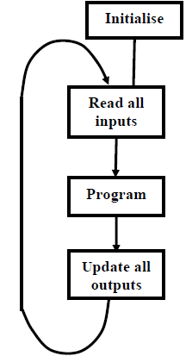

**Fig.4.3. The cyclic execution of PLC Programs**

## 4.3.15. Programming Languages

PLC programs can be constructed using various methods of representation. Some of the common ones are, described below.

**Ladder logic** is by far the most popular programming language in use because of its resemblance to hard-wire control diagrams. On its own, however it is unsuitable for complex programs. As the automation task grows so the ladder program expands organically, until only the original programmer can find his way through the tangle of inputs and outputs, relays and function blocks.

This problem has been solved by the use of **Sequential Function Chart** methods but the obvious popularity of ladder logic persists. The solution is to plan the program using a sequential function chart and then to enter it into the PLC using ladder logic. In this way program is highly structured, standardized and easy to debug and modify, while the familiarity of ladder logic is preserved.

### 4.3.16. PLC LADDER LOGIC PROGRAMMING

Ladder logic is the main programming method used for Programmable Logic Controller and has been developed to mimic relay logic. The decision to use the relay before, logic diagrams was a strategic one. By selecting ladder logic as the main programming method, the amount of retraining needed for engineers and tradespeople was greatly reduced. Modern control systems still include relays, but these are rarely used for logic. A relay is a simple electronic device that uses a magnetic to control a switch. Relays are used to let one power source close a switch for another(often high current) power source, while keeping them isolated. An example of a relay of simple control application is show below:

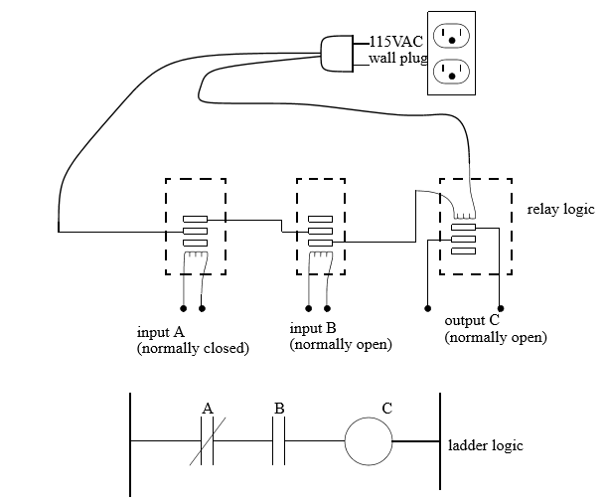

Fig.4.1 Simple relay control

A very commonly used method of programming PLCs is based on the use of ladder

diagrams. Writing a program is then equivalent to drawing a switching circuit. The ladder diagram consists of two vertical lines representing the power rails. Circuits are connected as horizontal lines, i.e., the rungs of the ladder, between these two verticals. Each rung consist of a set of inputs on the left end of the rung and a single output at the right end of each rung.

***In drawing a ladder diagram, certain conventions are adopted:***

1. The vertical lines of the diagram represent the power rails between which circuits are connected. The power flow is taken to be from the left-hand vertical across a rung.
2. Each rung on the ladder defines one operation in the control process.
3. A ladder diagram is read from left to right and from top to bottom, Figure 4.6 showing the scanning motion employed by the PLC. The top rung is read from left to right. Then the second rung down is read from left to right and so on.

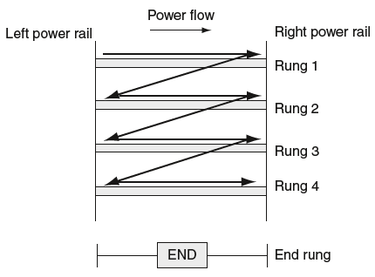

Fig.4.6. Scanning the ladder program

1. Electrical devices are shown in their normal condition. Thus a switch, which is normally open until some object closes it, is shown as open on the ladder diagram. A switch that is normally closed is shown closed.
2. Each rung must start with an input or inputs and must end with at least one output. The term input is used for a control action, such as closing the contacts of a switch, used as an input to the PLC. The term output is used for a device connected to the output of a PLC, e.g., a motor.
3. When the PLC is in its run mode, it goes through the entire ladder program to the end, the end rung of the program being clearly denoted, and then promptly resumes at the start. This procedure of going through all the rungs of the program is termed a cycle. The end rung might be indicated by a block with the word END or RET for return, since the program promptly returns to its beginning.
4. The inputs and outputs are all identified by their addresses, the notation used depending on the PLC manufacturer. This is the address of the input or output in the memory of the PLC.

Fig.4.7 shows the symbols that are used for input and output devices. Some slight variations occur between the symbols when used in semi-graphic form and when in full graphic. Note that inputs are represented by different symbols representing normally open or normally closed contacts. The action of the input is equivalent to opening or closing a switch. Output coils are represented by just one form of symbol.

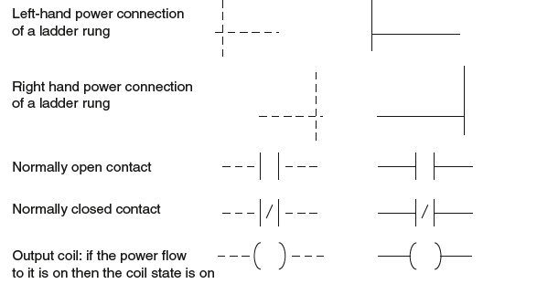

**Fig.4.7. Basic symbols**

To illustrate the drawing of the rung of a ladder diagram, consider a situation where the energizing of an output device, such as a motor, depends on a normally open start switch being activated by being closed. The input is thus the switch and the output the motor. Fig.4.8 shows the ladder diagram.

Starting with the input, we have the normally open symbol | | for the input contacts. There are no other input devices and the line terminates with the output, denoted by the symbol ( ). When the switch is closed, i.e., there is an input, the output of the motor is activated. Only while there is an input to the contacts is there an output. If there had been a normally closed switch | / | with the output , then there would have been an output until that switch was opened. Only while there is no input to the contacts is there an output.

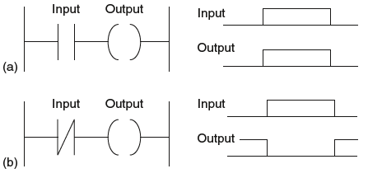

Fig.4.8. A ladder rung

#### 4.3.16.1 Conditional Logic

The PLC scans its inputs and, depending on the program, switches on or off various combinations of outputs. The logic state of the output depends on the input conditions and so the term ***conditional logic***is used. A simple example of conditional logic could be stated as follows:

* “A machine switches on if either of two *start* switches are closed and all of three *stop* switches are closed.” The conditions could be realized by a hard wire solution as shown in Fig.4.9.

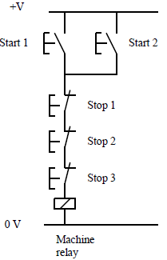

Fig.4.9.***Hard-Wire Conditional Logic Example***

The two *start* switches are connected in such way the current flows if one *or* the other *or* both are closed. The start switches are normally open. This means that the contacts are apart and no current flows when the switches are in their normal state.

The current can only flow if the first *and* the second *and* the third are closed. This means that the contacts are connected and current can flow when the switches are in closed mode.

#### 4.3.16.2 Ladder Diagrams and PLC wiring

To realize the conditional logic statement from Fig.4.9. using ladder logic we connect the switches to a PLC as shown in *Fig4.10.*

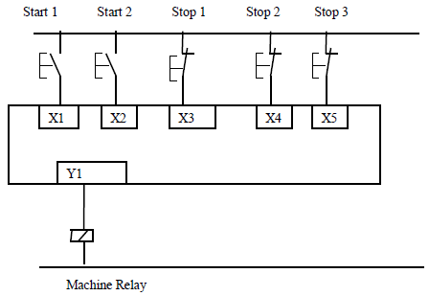

**Fig.4.10. PLC wiring**

To avoid later confusion regarding the concept of normally open (n/o) and normally closed (n/c) it is worth looking again at Fig 2.3 and remembering that the plc scans each input and asks “Is it on or is it off?” The five switches shown are external devices and the PLC knows nothing about them. As far as the PLC is concerned, at the moment, inputs X1 and X2 are off and X3, X4 and X5 are on.

The following figure shows a PLC ladder program using the TriLogi software:

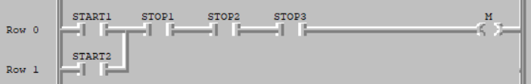

Fig.4.11. PLC ladder program

It can be seen from that the output *machine* will not be energized until one of the inputs *Start 1* or *Start 2* is switched on and all of the three *Stop* switches are in closed mode. If one of the three stop switches is open, this will de-energize the output.

#### 4.3.16.3 Normally closed contacts

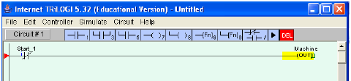

**Fig.4.12. Normally closed contact**

The contact Start 1 in Fig.4.10 will be closed when the input is switched off and so the output Machine will be switched on. Switching on the input opens the contact and switches the output off.

**Logic Functions**

There are many control situations requiring actions to be initiated when a certain combination of conditions is realized. Thus, for an automatic drilling machine, there might be the condition that the drill motor is to be activated when the limit switches are activated that indicate the presence of the workpiece and the drill position as being at the surface of the workpiece. Such a situation involves the AND logic function, condition A and condition B having both to be realized for an output to occur. This section is a consideration of such logic functions.

1. **AND Function**

This indicates a situation where an output is not energized unless two, normally open, switches are both closed. Switch A and switch B have both to be closed, which thus gives an AND logic situation. We can think of this as representing a control system with two inputs A and B . Only when A and B are both on is there an output.

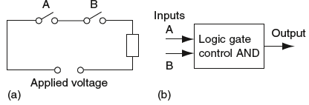

Fig.4.13. AND circuit and logic gate.

On a ladder diagram contacts in a horizontal rung, i.e., contacts in series, represent the

logical AND operations.

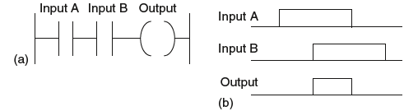

Fig.5.14. Ladder diagram for AND gate

* **OR Function**

This indicates an electrical circuit where an output is energized when switch A or B, both normally open, are closed. This describes an OR logic gate in that input A or input B must be on for there to be an output.

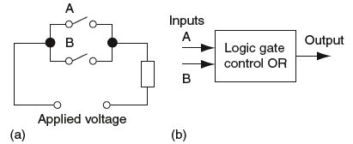

Fig.4.15. OR circuit and logic gate.

OR logic gate system on a ladder diagram is given by the below figure,

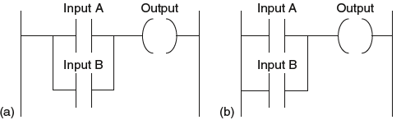

Fig.4.16. Ladder diagram for OR gate

* **NOT Function**

It describe an electrical circuit controlled by a switch that is normally closed. When there is an input to the switch, it opens and there is then no current in the circuit.

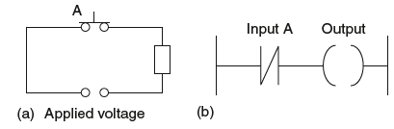

**Fig.4.17. NOT circuit and corresponded ladder diagram**

* **Exclusive OR (XOR)**

It gives an output when either of the inputs is 1 but not when both are 1.

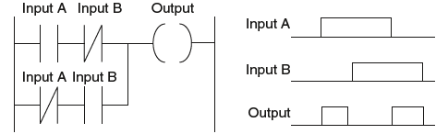

Fig.4.18.XOR gate ladder diagram

#### 4.3.16.4 Latching

There are often situations where it is necessary to hold an output energized, even when the input ceases. A simple example of such a situation is a motor, which is started by pressing a push button switch. Though the switch contacts do not remain closed, the motor is required to continue running until a stop push button switch is pressed. The term latch circuit is used for the circuit used to carry out such an operation. It is a self-maintaining circuit in that, after being energized, it maintains that state until another input is received.

An example of a latch circuit is shown in Fig.4.19. When the input S1 contacts close, there is an output. However, when there is an output, another set of contacts associated with the output closes. These contacts form an OR logic gate system with the input contacts. Thus, even if the input S1 opens, the circuit will still maintain the output energized. The only way to release the output is by operating the normally closed contact S2.

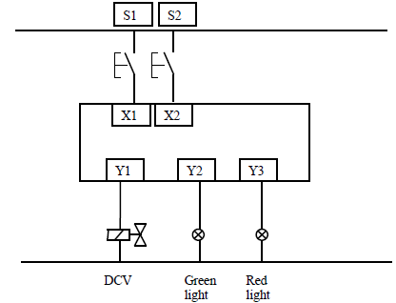

**Fig.4.19.plc wiring diagram**

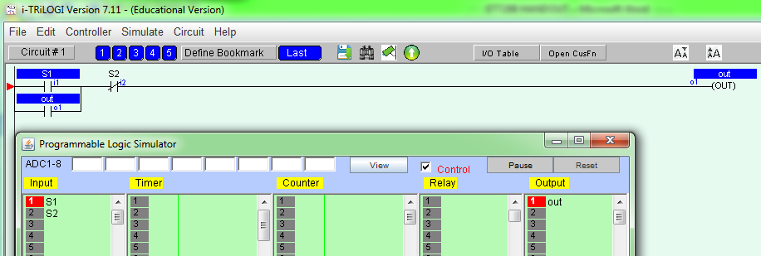

**Fig.4.20. ladder diagram(Switch S1 one is pressed)**

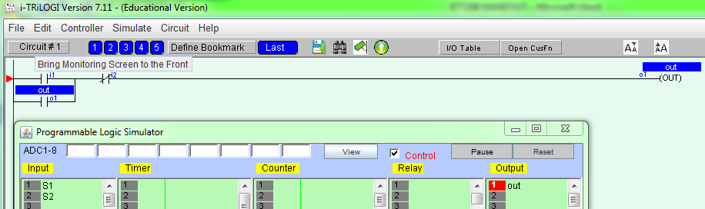

**Fig.5.21. Switch S1 is released**

Switching on the input S1 switches on the output out which in turn closes the associated switch.

**Example 4.1-**Write a PLC program to implement the conditional logic statements (a), (b) and (c) below.

a) A PLC output is to switch on if any of three inputs is switched on.

b) A PLC output is to switch on if any *one* of three inputs is switched on but not two or more.

c) A PLC output is to switch on if any two outputs are switched on, but not the third.

**Solution :**

(a)

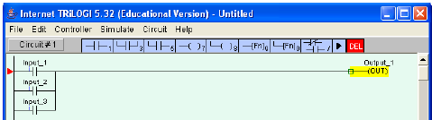

**(b)**

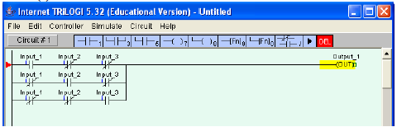

This program can be read: “The output switches on if Input 1 is on AND the other two are off, OR input 2 is on AND the other two are off, OR input three is on AND the other two are off.”

(c)

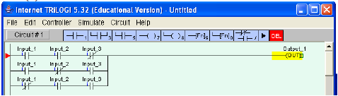

**Example2-Motor control using start and stop push button**

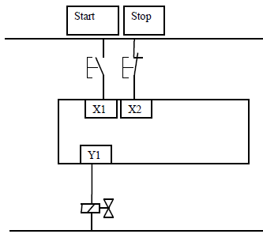

**Fig.4.22. plc wiring**

When the *start* push button switch in Fig.4.22is pressed, the output Y1 is to switch on and stay on until the *stop* button is pressed.

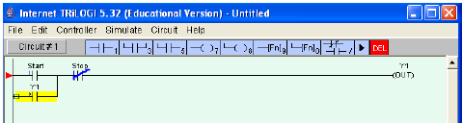

**Fig.4.23. ladder diagram**

When the output Y1 is energized we use a normally open contact of it in parallel with the *start* button to hold (or latch) it on. The output can only be de-energized by the pressing of the *stop* button. Note that we have used a normally closed switch as a stop button

**Exercise:** Write a ladder diagram to switch on the machine by using either start1 or start2 push buttons or stop it using either stop1or stop2 or stop3 push buttons.

#### 4.3.16.5 Internal relays

These have the same properties as outputs but they only exist in software. They have many uses. *Fig.4.24* shows an internal relay being used to implement the logic function NAND. This is the inverse of the result of X1 AND X2.

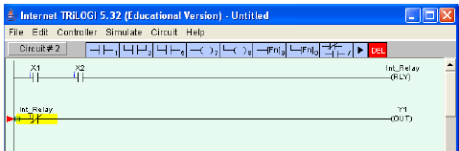

**Fig.4.24.**

#### 4.3.16.6 Timers

The delay-on timer introduces a delay between the start of one event and the start of another. For example, when a start push button is pressed, the pneumatic cylinder shown in *Fig.4.25* extends, remains extended for 5 seconds and then returns. The timer set value in the TRiLOGI software is in units of **0.1 s.** For a 5 s delay a value of 50 is entered in the drop-down menu. Draw the PLC wiring diagram and the appropriate ladder logic. Y1

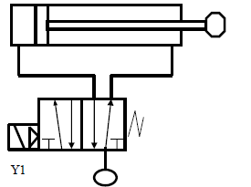

**Fig.4.25.** Pneumatic cylinder

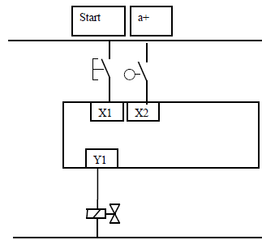

**Fig.4.26. plc wiring diagram**

The *start* button and the end-of-stroke limit switch *a+* are the PLC inputs and the solenoid Y1 is the output. Any other components needed for the program can be created in software.

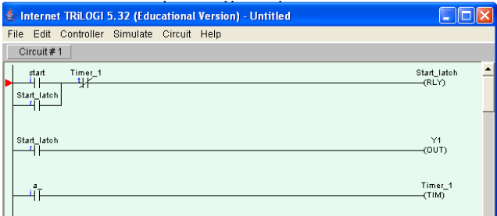

**Fig.4.27. Ladder diagram**

Pressing the *start* button latches on an internal relay called *start_latch*. The *start_latch* relay switches on the output Y1 which energizes the solenoid, and the cylinder extends. The cylinder rod closes the limit switch a+ which starts the timer in software. When the timer set value time has elapsed the normally-closed contact *Timer_1* in the first line of the program de-energizes the *Start_latch* relay and the cylinder returns.

**Exercise:** Using the same hardware with the addition of an alarm as a second output develop a ladder diagram to set alarm on during of 10seconds once the rod is closed to the limit switch and then after cylinder returns back:

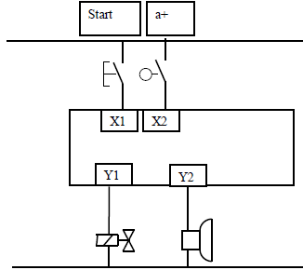

**Fig.4.28. plc wiring diagram**

The input to the delay-on timer must remain on for the duration of the timer set value otherwise the timer will not operate. If the signal to start the timer is only momentary then a latch is used to sustain it. When the input to the timer switches off, the timer contacts revert immediately to their normal states.

In some PLC models a timer function block can be is located in the centre of a rung as shown in Fig.4.29. When the timer set value has elapsed the timer output switches on allowing a software signal to energize an internal relay coil or an output. In this lecture all timer function blocks are located at the right hand side of the ladder diagram and their contacts, normally-open or normally closed, have the same label as the timer.

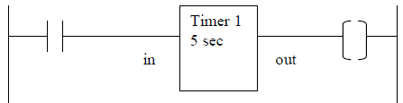

**Fig.4.29. delay-on timer ladder diagram**

The delay-off timer causes a delay between its input switching off and its contacts reverting to their normal states.

#### 5.8.1.7 COUNTERS

A counter allows a number of occurrences of input signals to be counted. The counter is set to a ***preset number value***and when this value of input pulses has been received, it will operate its contacts. A second input or software coil is provided to reset the *current value* of the counter to zero.

Example: Considering the following shaft

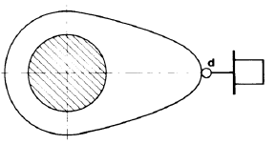

**Fig.4.30.**

When a ***start*** button has been pressed the shaft is to make 10 revolutions and then stop. Pressing the **start** button also resets the counter. The PLC wiring diagram is shown in Fig.4.31.

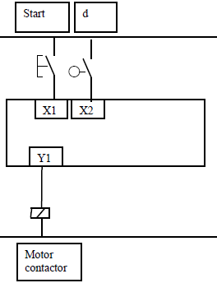

**Fig.4.31. Wiring diagram**

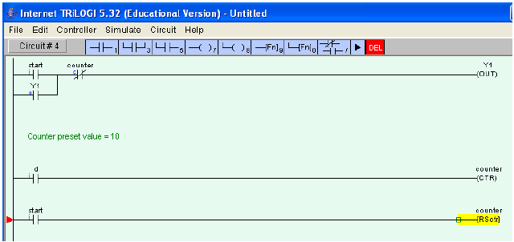

**Fig4.32. Ladder diagram**

The pulse generator and counter can be combined as shown in this final example. When a ***start* push button** is pressed and held down, an alarm sounds six times before a conveyor starts. Pressing the conveyor ***stop***button also resets the counter. **Fig.4.33.**and **Fig.4.34.**show a solution to the problem.

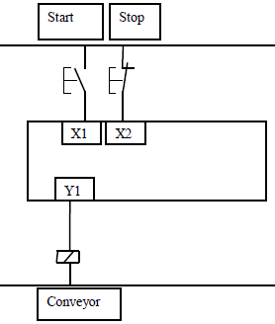

**Fig.4.33. wiring diagram**

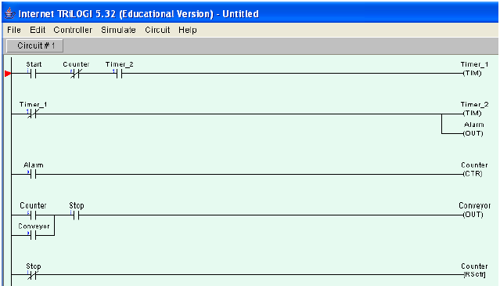

**Fig.4.34. ladder diagram**

## Questions and Exercises

1. Pick the correct statement below about the plc ladder

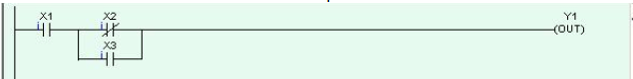

Answer:

1. Y1 switches on if X1 is off or either X2 is on AND X3 is off
2. Y1 switches on if X1 is on AND either X2 is off or X3
3. Y1 switches on if X1 is on or either X2 is off AND X3
4. Y1 switches on if X1 is off AND either X2 is on or X3
5. Pick the incorrect statement below about the ladder diagram shown

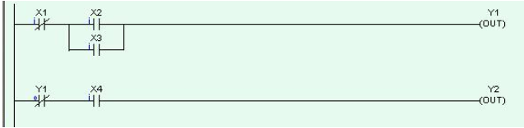

Answer:

|  |  |
| --- | --- |
| 1. Y2 switches on if X1 is on AND X2 AND X4 are on. 2. Y2 switches on if X1 is on AND X3 AND X4 are on 3. Y2 switches on if X1 is off AND X2 AND X3 are off AND X4 is on 4. Y2 switches on if Y1 AND X4 are both on |  |

1. Which form of logic gate system is given by a ladder diagram with a rung having two normally open sets in parallel as shown?

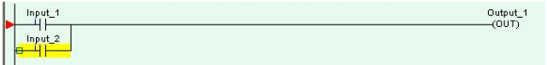

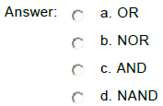

1. Which form of logic gate system is given by a ladder diagram with a rung having two normally open sets of contacts in series as shown?

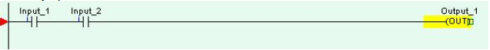

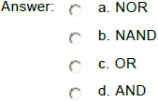

**The PLC wiring diagram *Fig 4.35* applies to questions 5-10.**

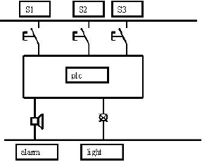

**Fig.4.35.**

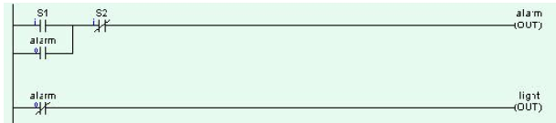

Pick the one correct statement below regarding the ladder diagram *:*

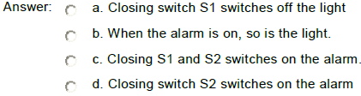

1. **Considering the following diagram**

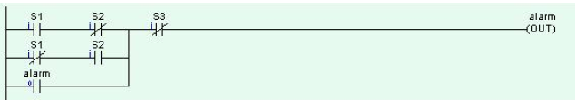

Pick the one correct statement below regarding the ladder diagram *:*

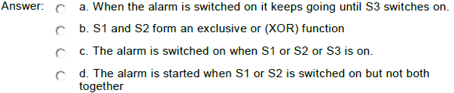

1. **Consider the following ladder diagram**

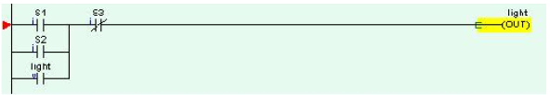

Pick the one correct statement below regarding the ladder diagram *:*

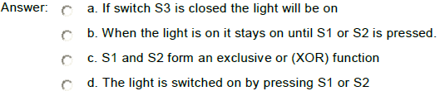

1. **Consider the following ladder diagram**

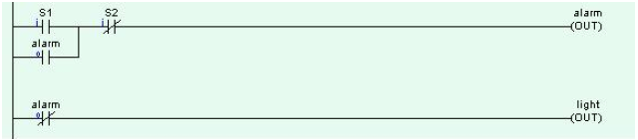

Pick the one correct statement below regarding the ladder diagram*:*

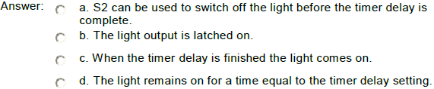

1. **Consider the following ladder diagram**

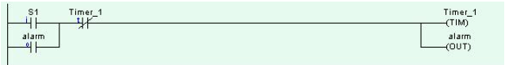

Pick the one correct statement below regarding the ladder diagram

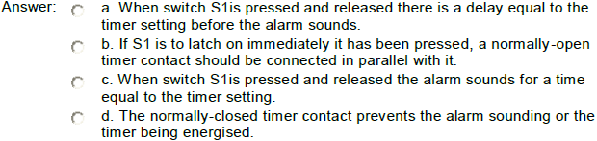

1. **Consider the following ladder diagram**

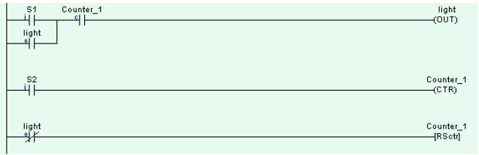

Pick the one correct statement below regarding the ladder diagram

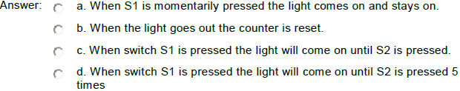

## Assigment1

1. A PLC is to be used to control a flood light. When a sensor with a normally open contact detects movement the light is to switch on for 10 seconds and then switch off. Draw the necessary PLC wiring diagram and the ladder logic to operate the system as designed.
2. A PLC is to be used to control the drive for a car window. When a momentary contact switch switch is pressed the window starts to open. If the switch is closed for more than 1 second, the window continues opening until fully open. A second switch does the same thing to close the window. Limit switches are provided to detect the window fully open or fully closed positions. Draw the necessary PLC wiring diagram and the ladder logic to operate the system as designed.
3. A PLC is used to control a conveyor system. A sensor with a normally open contact sees items passing on the conveyor. When 10 items have passed, the conveyor stops, a cylinder extends and retracts and the conveyor runs again until another 10 items have passed. Draw the necessary PLC wiring diagram and the ladder logic to operate the system as designed.

# 

# CHAP V: CONTROL SYSTEMS MODELLING

## 5.1. Introduction to Process Control

We often come across the term ***process***indicating a set up or a plant that we want to control. Thus by a process we may mean a unit of chemical plant ( a distillation column), or a manufacturing system ( an assembly shop), or a food processing industry and so on. A **control system** is a system of devices or set of devices; that manages, commands, directs or regulates the behavior of other device(s) or system(s) to achieve desire results. In other words the **definition of control system** can be rewritten as **a system, which controls other system**.

A bathroom toilet tank, a refrigerator, an air conditioner, a geezer, an automatic iron, an automobile all are control system. We find control system in quality control of products, weapons system, transportation systems, power system, space technology, robotics and many more. The **principles of control theory** are applicable to engineering and non-engineering field.

The main feature of control system is that, there should be a clear mathematical relation between input and output of the system. When the relation is represented by a linear proportionality, the system is called **linear control system**, otherwise a **non-linear control system**.

There are various **types of control system**; the system used for controlling the position, velocity, acceleration, temperature, pressure, voltage and current etc. are examples of control systems.

Manual control system required manual operation of the devices involved in the system while by the use of a sensor that measures the difference between the actual value and desired value then a control system may be automatic.

## 5.2. Characteristics of a Process

Different processes have different characteristics. But, broadly speaking, there are certain characteristics features those are more or less common to most of the processes. They are:

(i) *The mathematical model of the process is nonlinear in nature.*

(ii) *The process model contains the disturbance input*

In general a process may have several input variables and several output variables. But only one or two (at most few) of the input variables are used to control the process. These inputs, used for manipulating the process are called ***manipulating variables*.** The other inputs those are left uncontrolled are called ***disturbances***. Few outputs are measured and fed back for comparison with the desired set values. The controller operates based on the error values and gives the command for controlling the manipulating variables. The block diagram of such a closed loop process can be drawn as shown in Fig.5.1.

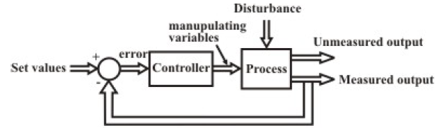

**Fig.5.1. General Description of a closed loop process**

In order to understand the behavour of a process, let us take up a simple open loop process as shown in Fig.5.2. It is a tank containing certain liquid with an inflow line fitted with a valve V1 and an outflow line fitted with another valve V2. We want to maintain the level of the liquid in the tank; so the ***measured output* variable** is the liquid level *h*. It is evident from Fig5.2. That there are two variables, which affect the measured output. These are the throttling of the valves V1 and V2. The valve V1 is in the inlet line, and it is used to vary the inflow rate, depending on the level of the tank. So we can call the inflow rate as the manipulating

variable. The outflow rate (or the throttling of the valve V2 ) also affect the level of the tank, but that is decided by the demand, so not in our hand. We call it a *disturbance* (or sometimes as *load*).

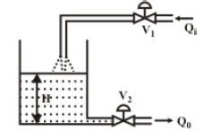

**Fig.5.2. Example of physical process**

The major feature of this process is that it has a single input (manipulating variable) and a single output (liquid level). So we call it a *Single-Input-Single-Output* (SISO) process.

## 5.3. Laplace Transform

**Laplace Transform:** Laplace transforms convert differential equations into algebraic equations. They are related to frequency response. Thus Laplace transform are used for solving differential equations.

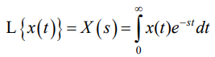

The following table summarize the Laplace transform of different mathematical functions.

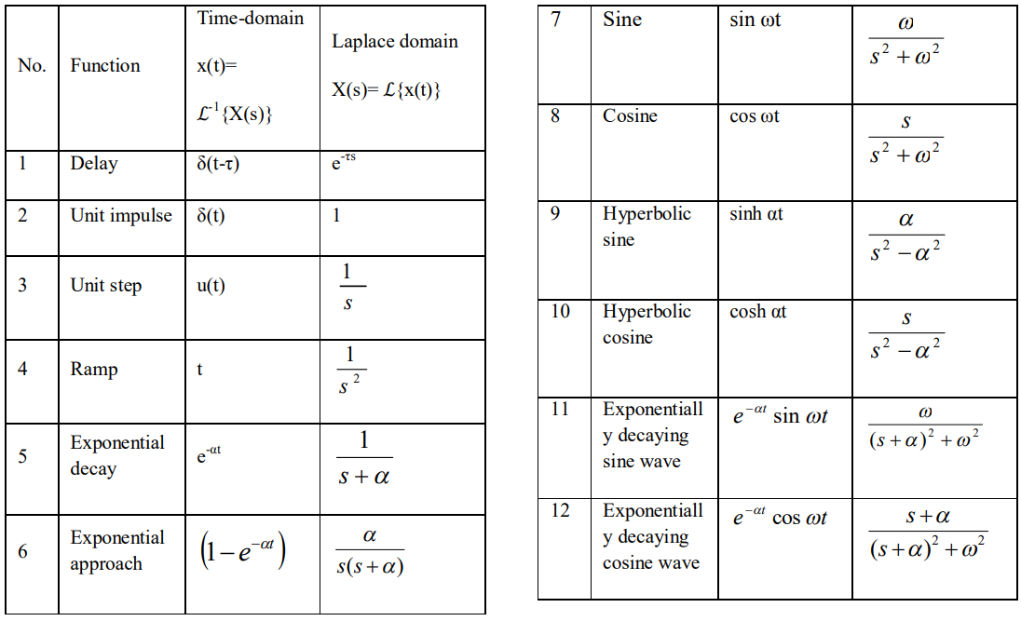

**Solution of system dynamics in Laplace form:**

Laplace transforms can be solved using different techniques and these techniques include:

* Unrepeated factors
* Unrepeated complex factors

1. **Unrepeated factors**

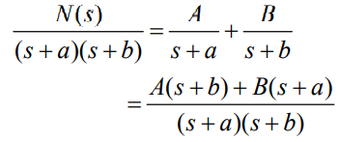

By equating both sides, determine A and B.

**Example:** Expand the following equation of Laplace transform in terms of its partial fractions and obtain its time-domain response.

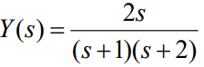

**Solution:** The following equation in Laplace transform is expanded with its partial fractions as follows.

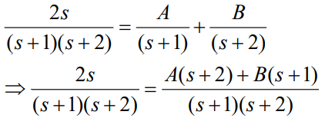

By equating both sides, A and B are determined as A=-2 , B = 4 . Therefore,

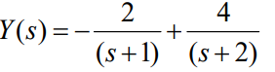

Taking Laplace inverse of above equation,



**(ii) Unrepeated factors**

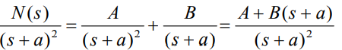

By equating both sides, determine A and B.

**Example:** Expand the following equation of Laplace transform in terms of its partial fractions and obtain its time-domain response.

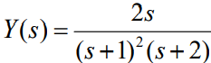

**Solution:** The following equation in Laplace transform is expanded with its partial fractions as follows.

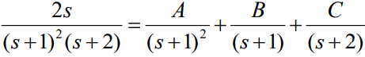

By equating both sides, A and B are determined as A =-2, B = 4, C=4 . Therefore,

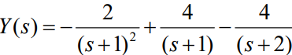

Taking Laplace inverse of above equation,



**(iii)Complex factors:** They contain conjugate pairs in the denominator.

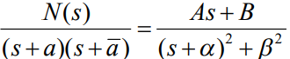

**Exercise:**

Expand the following equation of Laplace transform in terms of its partial fractions and obtain its time-domain response.

## 5.4. Transfer function

An important step in the analysis and design of control systems is the mathematical model of

the controlled process. There are a number of mathematical representations to describe a controlled process: **Transfer function and differential equation**

***Transfer function*** is defined as the ratio of the Laplace transform of the output variable to the Laplace transform of the input variable, with all zero initial conditions.

**Linear Time-Variant and Linear Time-Invariant Systems**

**A *time-variable differential equation***is a differential equation with one or more of its coefficients are functions of time, t. For example, the differential equation:



**A *time-invariant differential equation***is a differential equation in which none of its

coefficients are dependent of time variable, t. For example, the differential

equation:



* **Transfer Function of Linear Time-Invariant (LTI) Systems**

The transfer function of a linear, time-invariant system is defined as the ratio of the Laplace transform of the output (response function), Y(s), to the Laplace transform of the input

(driving function) U(s), under the assumption that all initial conditions are zero.



Taking the Laplace transform with zero initial conditions,





Where G(s) = M(s)/N(s) is the transfer function of the system; the roots of N(s) are called ***poles***of the system and the roots of M(s) are called ***zeros***of the system. By setting the denominator

function to zero, we obtain what is referred to as the ***characteristic equation***

***To derive the transfer function of a system, we use the following procedures:***

1. Develop the differential equation for the system by using the physical laws, e.g.

Newton’s laws and Kirchhoff’s laws.

2. Take the Laplace transform of the differential equation under the zero initial conditions.

3. Take the ratio of the output Y(s) to the input U(s). This ratio is the transfer function.

Example: Determine the transfer function of the system shown in Fig.5.3.

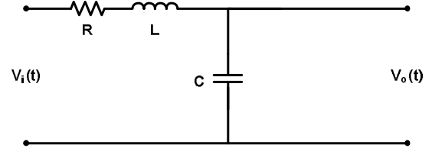

Fig.5.3. a system in time domain

**Solution:** Fig.5.3 is redrawn in frequency domain as shown in Fig.5.4.

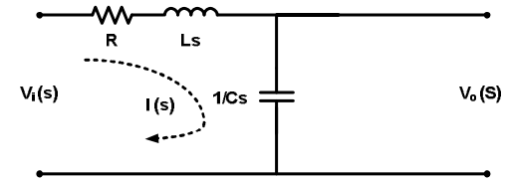

Fig.5.4. a system in frequency domain

Applying KVL to loop-1 of the Fig.5.4.

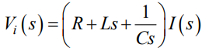

Applying KVL to loop-2 of the Fig.5.4.

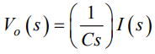

By combining those above equations we get:

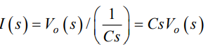

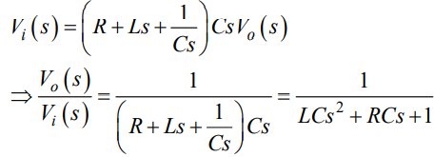

Then transfer function of the given system is



Exercise: Consider the following RC circuit.

1. Find the transfer function of the network,

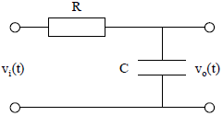

Fig.5.5

## 5.5 System Block Diagram

A block diagram of a system is a pictorial representation of the functions performed by each

component and of the flow of signals. It is the pictorial representation of the relationship between input and output of a physical system. The block diagram gives an overview of the system.

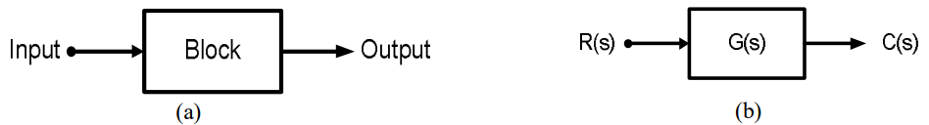

Fig.5.6. (a) A block diagram representation of a system and (b) A block diagram representation with gain of a system

**Output:** The value of input multiplied by the gain of the system.



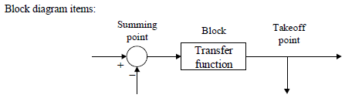

Fig.5.7

The above figure shows the way the various items in block diagrams are represented. Arrows are

used to represent the directions of signal flow. A summing point is where signals are algebraically added together or subtracted. The takeoff point is similar to the electrical circuit takeoff point. The block is usually drawn with its transfer function written inside it.

We will use the following terminology for block diagrams throughout this course:

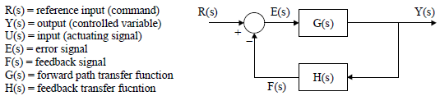

* **Single block:**



U(s) is the input to the block, Y(s) is the output of the block and G(s) is the transfer function of the block.

**Block diagram Simplification:**

* **Series connection:**



* **Parallel connection (feed forward):**

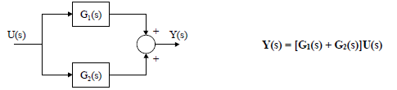

* **Negative feedback system (closed-loop system):**

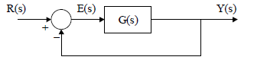



**Exercise1**: Find the closed-loop transfer function for the following block diagram:

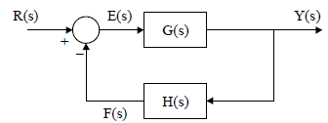

**Exercise2**: A control system has a forward path of two elements with transfer functions K and

1/(s+1) as shown. If the feedback path has a transfer function s, what is the transfer function of the closed loop system?

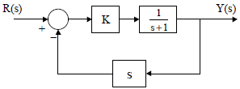

Fig5.8

**Exercise3:** Reduce the following block diagram and determine the transfer function.

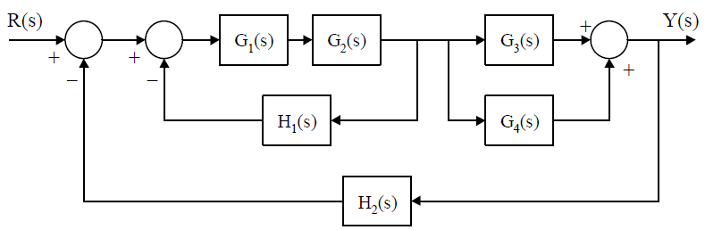

Fig5.9

## 5.6. P-I-D Control

* **Introduction**

In the previous section, a brief introduction about a process control system has been given. The basic control loop can be simplified for a single-input-single-output (SISO) system as in Fig.5.10. Here we are neglecting any disturbance present in the system.

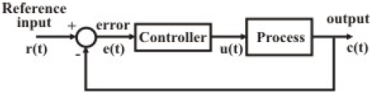

**Fig.5.10. A closed loop SISO system**

The controller may have different structures. Different design methodologies are there for designing the controller in order to achieve desired performance level. But the most popular among them is Proportional-Integral-derivative (PID) type controller. In fact more than 95% of the industrial controllers are of PID type. As is evident from its name, the output of the PID controller u(t) can be expressed in terms of the input e(t), as:

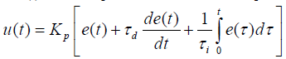

and the transfer function of the controller is given by:



The terms of the controller are defined as:

** **

In the following sections we shall try to understand the effects of the individual components- proportional, derivative and integral on the closed loop response of this system. For the sake of simplicity, we consider the transfer function of the plant as a simple first order system without time delay as:



### 5.7. Proportional control

With the proportional control action only, the closed loop system looks like:

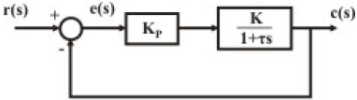

**Fig.5.11. Proportional control**

Now the closed loop transfer function can be expressed as:

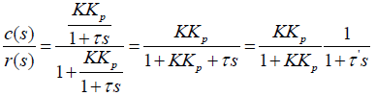 

For a step input ***r*(*s*),** the system response is shown in Fig.3.5.

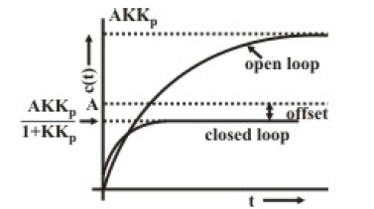

**Fig.5.12. Response with proportional controller**

From Fig.5.12, it is apparent that:

1. The time response improves
2. There is a steady state offset between the desired response and the output response =



This offset can be reduced by increasing the proportional gain; but that may also cause increase oscillations for higher order systems. The offset, often termed as “**steady state error**” can also be obtained from the error transfer function and the error function *e(t)* can be expressed in terms of the Laplace transformation form:

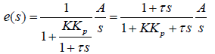

Using the final value theorem, the steady state error is given by:

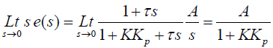

### 5.8. Integral Control

If we consider the integral action of the controller only, the closed loop system for the same process is represented by the block diagram as shown in Fig.5.13.

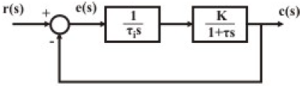

**Fig.5.13. Integral control action**

Proceeding in the same way as in proportional control, in this case, we obtain,

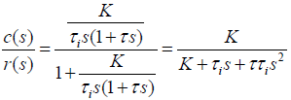

From the first observation, it can be seen that with integral controller, the order of the closed loop system increases by one. This increase in order may cause instability of the closed loop system, if the process is of higher order dynamics.



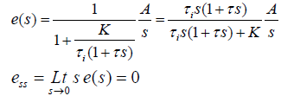

So the major advantage of this integral control action is that the **steady state error due to step input reduces to zero**. But simultaneously, **the system response is generally slow,** **oscillatory** and unless properly designed, **sometimes even unstable.** The step response of this closed loop system with integral action is shown in Fig.5.14.

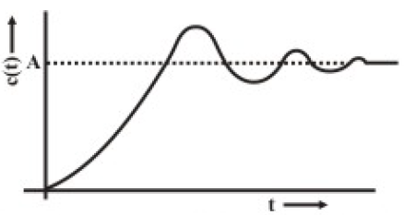

**Fig.5.14. Step response with integral control action**

### 5.9. Proportional Plus Integral (P-I) Control

With P-I controller the block diagram of the closed loop system with the same process is given in Fig.5.15.

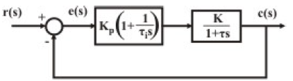

**Fig.5.15. proportional with integral control action**

It is evident from the above discussions that the P-I action provides the dual advantages of **fast response** due to P-action and the **zero steady state error** due to I-action. In the same way as in integral control, we can conclude that the steady state error would be zero for P-I action.

So we can conclude that by using P-I control, the steady state error can be brought down to zero, and simultaneously, the transient response can be improved. The output responses due to (i) P, (ii) I and (iii) P-I control for the same plant can be compared from the sketch shown in Fig.5.16.

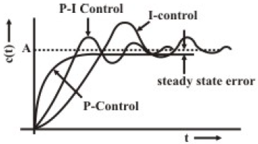

**Fig.5.16. Comparison among the transient response with P,I and P-I control**

### 5.10. Proportional plus Derivative (P-D) Control

The transfer function of a P-D controller is given by:



P-D control for the process transfer function,



Apparently is not very useful, since it cannot reduce the steady state error to zero. But for higher order processes, it can be shown that the **stability of the closed loop system can be improved** using P-D controller.

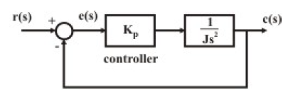

**Fig.5.17. Control action with higher order process**

The step responses of this process with P and P-D controllers are compared in Fig.5.18.

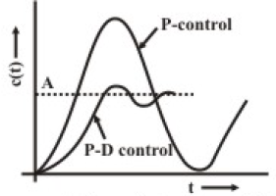

**Fig.5.18. Improvement of the transient response with P-I control**

### 5.11. Proportional-Integral-Derivative (PID) control

It is clear from above discussions that a suitable combination of proportional, integral and derivative actions can provide all the desired performances of a closed loop system. The transfer function of a P-I-D controller is given by:



The order of the controller is low, but this controller has universal applicability; it can be used in any type of SISO system, e.g. linear, nonlinear, time delay etc. Many of the MIMO systems are first decoupled into several SISO loops and PID controllers are designed for each loop. PID controllers have also been found to be robust, and that is the reason, it finds wide acceptability for industrial processes. However, for proper use, a controller has to be tuned for a particular process; i.e. selection of P,I,D parameters are very important and process dependent. Unless the parameters are properly chosen, a controller may cause instability to the closed loop system.

It is not always necessary that all the features of proportional, derivative and integral actions should be incorporated in the controller. In fact, in most of the cases, a simple P-I structure will suffice.

## 5.12. Selection of controller mode

1. **Proportional Controller:** It is simple regulating type; tuning is easy. But it normally introduces steady state error. It is recommended for process transfer functions having a pole at origin, or for transfer functions having a single dominating pole;
2. **Integral Controller:** It does not exhibit steady state error, but is relatively slow responding. It is particularly effective for:
3. **Proportional plus Integral (P-I) Control:** It does not cause offset associated with proportional control. It also yields much faster response than integral action alone. It is widely used for process industries for controlling variables like level, flow, pressure, etc., those do not have large time constants.
4. **Proportional plus Derivative (P-D) Control:** It is effective for systems having large number of time constants. It results in a more rapid response and less offset than is possible by pure proportional control. But one must be careful while using derivative action in control of very fast processes, or if the measurement is noisy (e.g. flow measurement).
5. **Proportional plus Integral plus Derivative (P-I-D) Control:** It finds universal application. But proper tuning of the controller is difficult. It is particularly useful for controlling slow variables, like pH, temperature, etc. in process industries.

## 5.13. Controller Tuning

It was also mentioned that the controller could be easily incorporated in a process, whatever be the type of a process: linear or nonlinear. It is needless to say that the controller parameters influence heavily the performance of the closed loop system. Again**, the choice of the value** of **the P, I and D parameters** is very much **process dependent**. As a result, thorough knowledge about the plant dynamics is important for selection of these parameters.

In most of the cases, it is difficult to obtain the exact mathematical model of the plant. So, we have to rely on the **experimentation** for finding out the optimum settings of the controller for a particular process. The process of **experimentation** for obtaining the optimum values of the controller parameters with respect to a particular process is known as **controller tuning.**

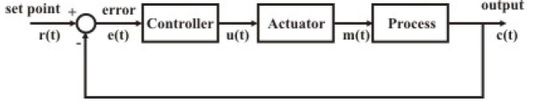

**Fig.5.19. Closed loop system**

The error signal is fed to the controller and the controller provides output u(t). Since the capacity of the controller to deliver output power is limited, an actuator is needed in between the controller and the process, which will actuate the control signal. It may be a valve positioner to open or close a valve; or a damper positioner to control the airflow through a damper. The controller considered here is a P-I-D controller whose input and output relationship is given by the equation:

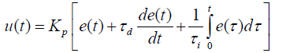

Our objective is to find out the optimum settings of the P,I,D parameters, namely *Kp*, τ*d* and τ*i* through experimentation, which will provide satisfactory closed loop performance, of the particular process in terms of, say, stability, overshoot, setting time etc. The one of methods of tuning are elaborated in the following sections.

### 5.13.1. Closed Loop Technique (Continuous Cycling method)

For tuning the controller when the process is in under closed loop operation, there are two methodologies. The first one, continuous cycling method is explained below.

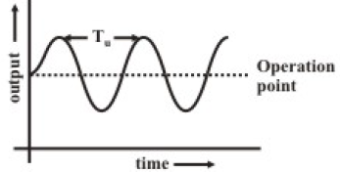

**Fig.5.20. Controller tuning continuous oscillation mode**

Referring Fig.5.20, the loop is closed with the controller output connected to the actuator input. Here, the controller is first set to P-mode, making τ*d=0 and* τ*i*=∞. The proportional gain *Kp* is increased gradually to ***Kp* = *Kp max***till the system just starts oscillating with constant amplitude continuously. The output waveform is plotted as shown in Fig.5.20. The time period of continuous oscillation **T*u***is noted. The recommended optimum settings are:

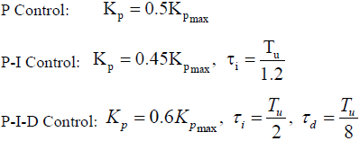

## 5.13.2. Electronic PID Controllers

Electronic PID controllers can be obtained using operational amplifiers and passive components like resistors and capacitors. A typical scheme is shown in Fig.5.21. With little calculations, it can be shown that the circuit is capable of delivering the PID actions as:



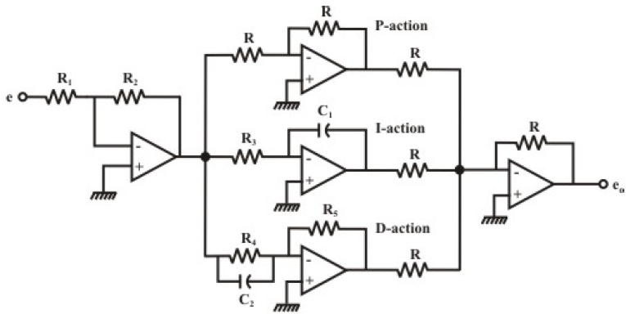

**Fig.5.21. Electronic PID controller (analog)**

It is evident from Fig.5.21, the proportional gain *Kp* is decided by the ratio ***R*2/*R1***of the first amplifier; the integral action is decided by *R*3 and *C*1 and the derivative action by *R*5 and *C*2. The final output the integral action is decided by *R*3 and *C*1 and the derivative action by *R*5 and *C*2. The final output however comes out with a negative sign comparing with equation, (though the positive sign can also be obtained by using a non-inverting amplifier at the input stage, instead of the inverting amplifier). The op. amps. Shown in the circuits are assumed to be ideal.

Today, digital controllers are being used in many large and small-scale control systems,

replacing the analog controllers. It is now a common practice to implement PID

controllers in its digital version, which means that they operate in discrete time domain

and deal with analog signals quantized in a limited number of levels. Moreover, in such

controller we do not need much space and they are not expensive.

**REFRENCES**

[1] Vidya Muthukrishnan, “Programmable Logic Controllers (PLCs): Basics, Types & Applications,” 2019. [Online]. Available: https://www.electrical4u.com/programmable-logic-controllers/.

**[2].** <https://nijas2012.home.blog/actuators>

[3]. <https://nptel.ac.in/courses/112106175/Module%204/Lecture%2037.pdf>

[4]. <https://nptel.ac.in/courses/112106175/Module%202/Lecture%2012.pdf>

[5]. <http://www.freestudy.co.uk/control/t2.pdf>

[6]. <http://www.idconline.com/technical_references/pdfs/mechanical_engineering/Types_of_the_Actuators%20.pdf>

[7] “Introduction to control system Engineering, ”. [Online]. Available on: <https://uomustansiriyah.edu.iq/media/lectures/5/5_2018_03_14!04_35_43_PM.pdf>

[8] “Introduction to Control Systems,”. [Online]. Available on: <http://www.ent.mrt.ac.lk/~rohan/teaching/EN5001/Reading/DORFCH1.pdf>

[9]<https://www.tutorialspoint.com/control_systems/control_systems_introduction.htm#:~:text=A%20control%20system%20is%20a,diagram%20of%20a%20control%20system.&text=Accordingly%2C%20the%20input%20signal%20controls%20the%20output>.

[10] [Carlos Gonzalez](https://www.machinedesign.com/home/contact/21838489/carlos-gonzalez), "What is Programmable Logic Controller?,". [Online]. Available on: <https://www.machinedesign.com/learning-resources/engineering-essentials/article/21834250/engineering-essentials-what-is-a-programmable-logic-controller>